Course Title: | Field Training
Course Code: | 473CCN-4
Program: | Bachelor of Science in Computer Networks
Department: | Department of Networks and Communication Engineering
College: | College of Computer Science and Information Systems
Institution: | Najran University

Field Experience Specifications

Institution:  Najran university | Date of Report
College: Faculty of Computer Science and information Systems  Program:  Bachelor of Science in Computer Networks | Department: Department of Networks and Communication Engineering  Track (if any):
A. Field Experience Course Identification and General Information
1. Field experience course title and code: Field Training/Summer Training 473CCN-4

2. Credit hours (if any): 4

3. Level or year of the field experience. After finishing >60 credit hours

4. Dates and times allocation of field experience activities.

a. Dates: Duration of 200 hours of training during the eight weeks in Summer Semester
b. Times: from 8:00 am to 2:30 pm (5 hours daily )
5. List names, addresses, and contact information for all field experience locations.

 | Name and Address  of the Organization | Name of Contact Person | Contact Information  (email address or mobile
a. | Department of Information Technology. Najran University
b. | Najran Muncipility
c. | Najran Police Department
d. | Najran Education office
e.

B. Learning Outcomes
Learning Outcomes for Field Experience in Domains of Learning, Assessment Methods and Teaching Strategy
1. List learning outcomes for the field experience.

- Provide students with practical experience.
- Adapt the work environment.
- Work effectively in a team with taking responsibility.
- Linking theoretical study with the practical reality.
- Communicate with others.
- Provide an opportunity for companies / institutions to identify distinctive cadres in order to attract when they graduate to work.
- Writing preparation of technical reports.
- Gain experience of engineers, technicians and identify their working lives.
2. Learning Outcomes in Domains of Learning, Assessment Methods and Teaching Strategy

 | NQF Learning Domains  and Learning Outcomes | Teaching  Strategies | Assessment  Methods
1.0 | Knowledge
1.1 | Record skills gainful daily | 1.1 | Record skills gainful daily
1.2 | List all Gained Skills | 1.2 | List all Gained Skills
2.0 | Cognitive Skills
2.1 | Develop technical skills | 2.1 | Develop technical skills
2.2 | Create a spirit of innovation | 2.2 | Create a spirit of innovation
3.0 | Interpersonal Skills & Responsibility
3.1 | Demonstrate the skills required in the work environment | 3.1 | Demonstrate the skills required in the work environment
3.2 | Use the personal skills to gain practical experience from co-workers | 3.2 | Use the personal skills to gain practical experience from co-workers
4.0 | Communication, Information Technology, Numerical
4.1 | Operate new software and Hardware | 4.1 | Operate new software and Hardware
4.2 | Assess the current technology used in organization | 4.2 | Assess the current technology used in organization
5.0 | Psychomotor
5.1
5.2

C. Description of Field Experience Activity
1. Describe the major student activities taking place during the field experience.
- Compliance with the rules and regulations of the work.
- Send required forms to the department head at the college in a timely manner using the mail address.
- Coordination with the supervisor of the training company regarding the final evaluation during the training period and send it to make sure the department head.
- Writing the final report on the summer training and submit it to the department head.
- Presentation and discussion of the final report at the beginning of the Fall semester.

2. List required assignments, projects, and reports.
- Sending weekly report includes the work done during the week.
b. Writing the final report progressively.
c. Preparing the final presentation progressively.
d. Doing all assignments that required from organization
3. Follow up with students. What arrangements are made to collect student feedback?

Receiving feedback of students through several channels:
- Via e-mail.
- Via mobile phone.
- Via Social Media

4. Insert a field experience flowchart for responsibility and decision-making (including a provision for conflict resolution).
Receipt of acceptance from the department head to the training place.
Completion of the training period
Start Summer Training
If there are any Problem in summer training
Contact with Department Head

5. Responsibilities.

 | Student | Field Teaching Staff | Program Faculty and Teaching Staff | Department or College
Planning Activities
a. Student activities.
b. Learning experiences.
c. Learning resources
d. Field site preparations
e. Student guidance and support
Supervision Activities
a. transport to and from site.
b. Demonstrate learning outcome performance.
c. Completion of required tasks, assignments, reports, and projects.
d. Field site – safety.
e. Student learning activities.
b. Providing learning resources
c. Administrative (attendance)
Assessment Activities
a. Student learning outcomes
b. Field experience
c. Field teaching staff
d. Program faulty and teaching staff
e. Field site
f. Learning resources

b. Explain the student assessment process.
No. | Evaluation topic | Marks
1 | Weekly report | 15%
2 | Final evaluation (company) | 35%
3 | Final report | 35%
4 | Final presentation | 15%
# | Total Marks | 100%

c. Explain the resolution of differences process (If the field teaching staff and the program faculty and teaching staff share responsibility for student assessment, what process is followed for resolving differences between them?) : The process varies per location. Hence it should be part of the agreement between both sites.

D Planning and Preparation
- Identification of Field Locations
 | List Requirements for Field Site Locations  (IT, equipment, labs, rooms, housing, learning resources, clinical) | List Safety Standards | List Specialized Criteria
 | A. Quality of Information Technology Center. | Must be compatible with the standards of security followed by the Telecommunications Authority and Information Technology | Must cover the basic disciplines of Computer
 | b. Availability of modern software | Must be compatible with the standards of security followed by the Telecommunications Authority and Information Technology | Must provide a better and latest software
 | c. Availability of modern hardware | Must be compatible with the standards of security followed by the Telecommunications Authority and Information Technology | Must provide a better and latest hardware
 | d. The availability of specialized technical centers | Must be compatible with the standards of security followed by the Telecommunications Authority and Information Technology | Must provide the latest techniques and specialized programs in the same field
2. Explain the decision-making process used to determine appropriate field experience locations.
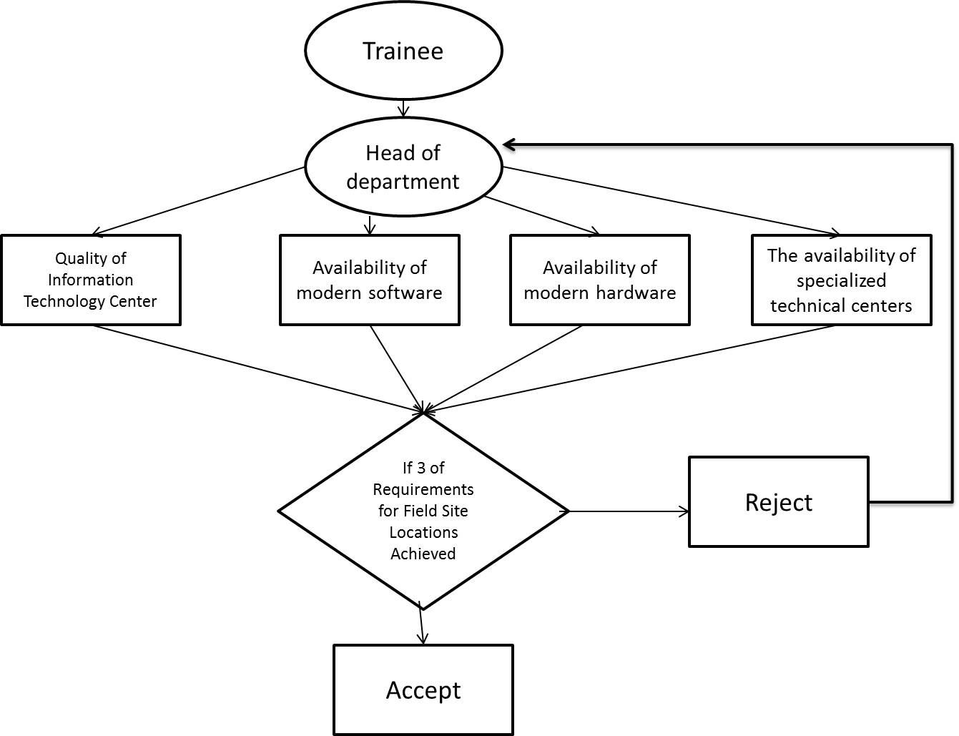

2. Identification of Field Staff and Supervisors
List Qualifications | List Responsibilities | List Training Required
a. Holds no less than bachelor. | a. supervision
- At least has 3 year work experience | - Provide training
c. Holds a degree science in information Systems or related field. | c. report on progress
d. | d. follow the requirements
Explain the decision-making process used to determine appropriate field staff and supervisors.

3. Identification of Students
List Pre-Requisite Requirements | List Testing Requirements | List Special Training Required
a. The Student must complete 90 credit hours. | No special requirements | No special requirements
b. Students are not allowed to take other courses during the summer training | No special requirements | No special requirements
c.
d.
Explain the decision-making process used to determine that a student is prepared to enroll in field experience activities.

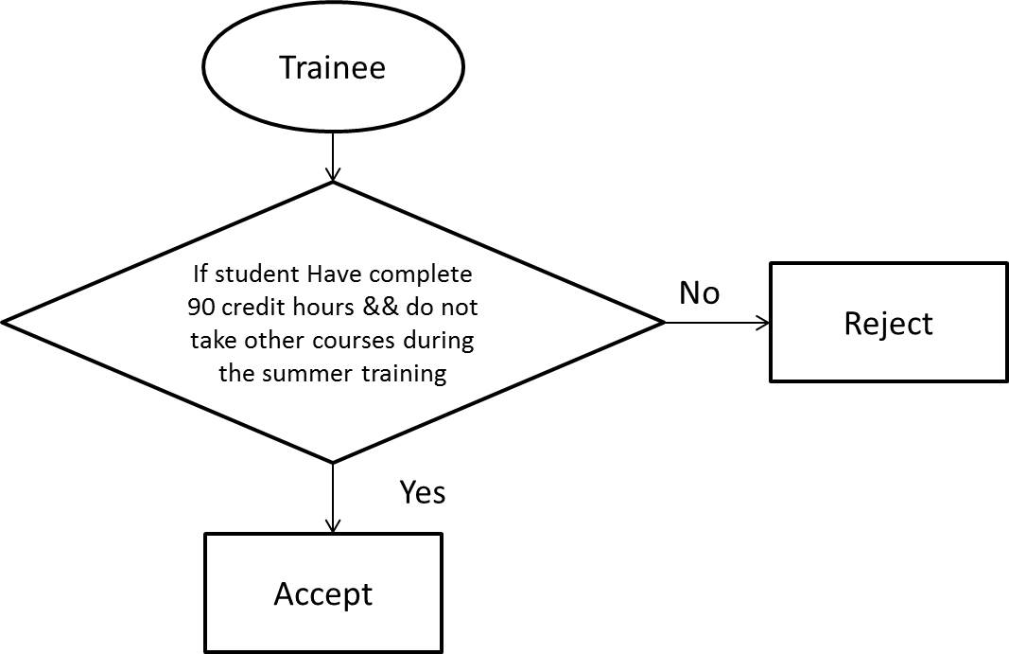
4. Safety and Risk Management.
List Insurance Requirements | List Potential Risks | List Safety Precautions Taken | List Safety Training Requirements
a. Not to expel the trainee of the program without giving convincing reasons. | The expulsion of training without compelling reasons | Contract an agreement with the company. | Select companies with an agreement in advance.
b. carrying all damages infected trainee during training | Injury the trainee during summer training | Contract an agreement with the company. | Select companies with an agreement in advance.
c. Bear all the financial requirements of the training. | Claim the college with the financial receivables | Contract an agreement with the company. | Select companies with an agreement in advance.
d.
Explain the decision-making process used to protect and minimize safety risks.
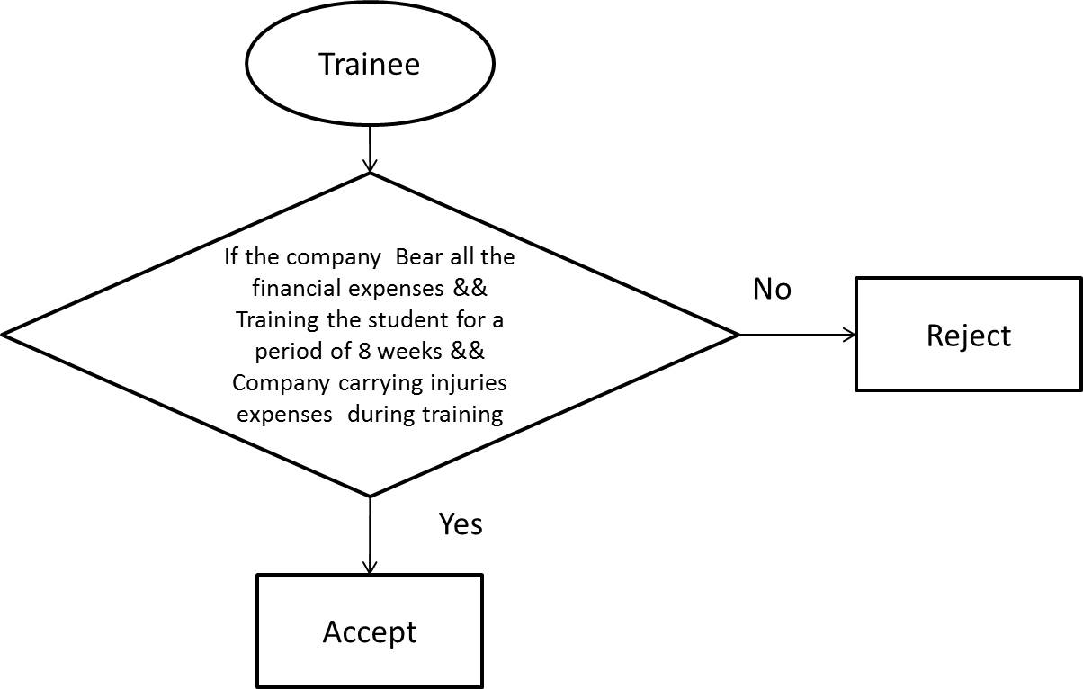

5. Resolution of Differences in Assessments. If supervising staff in the field location and faculty from the institution share responsibility for student assessment, what process is followed for resolving any differences between them?
See above 5c

E. Evaluation of the Field Experience
1. Describe the evaluation process and list recommendations for improvement of field experience activities by:
a. Students
Describe evaluation process
- Send a Weekly report.
- Doing a Final report.
- Doing a Final presentation.

List recommendations for improvement
- Show the importance of training for students
- Show the importance of learning new skills
- Show the importance of applying the skills learned

b. Supervising staff in the field setting
Describe evaluation process
- Fill the evaluation forms.
- Fill in a questionnaire to assess the Summer Training.

List recommendations for improvement
- Develop a new evaluation form that covers more criteria.
- Develop more than one evaluation e.g. technical evaluation, managerial evaluation.

c. Supervising faculty from the institution
Describe evaluation process
- Evaluating the weekly reports.
- Evaluating the final report.
- Evaluating the final presentation.

List recommendations for improvement
- Doing a workshop describes the goals of training.
- Also describes the objective of training.
- Show the importance from training.
e. Others—(e.g. graduates, independent evaluator, etc.)
na

 | 2. Action Plan for Improvement for Next Semester/Year
Actions Recommended |  | Intended Action Points  and Processes | Start  Date | Completion  Date | Person Responsible

Name of Field Experience Coordinator: ___Dr. Mohamed Khairi ________________________________________

Signature: ______________________ Date Specification Completed: January 20, 2019

Program Coordinator: _____________________________________________________

Signature: _________________________ Date Received: ___________________

