Course Title: | Graduation Project 2
Course Code: | 572CCN-3
Program: | Bachelor of Science in Computer Networks
Department: | Department of Computer Networks
College: | College of Computer Science and Information Systems
Institution: | Najran University

Table of Contents
A. Course Identification 3
6. Mode of Instruction (mark all that apply) 3
B. Course Objectives and Learning Outcomes 3
1. Course Description 3
2. Course Main Objective 3
3. Course Learning Outcomes 3
C. Course Content 4
D. Teaching and Assessment 4
1. Alignment of Course Learning Outcomes with Teaching Strategies and Assessment Methods 4
2. Assessment Tasks for Students 4
E. Student Academic Counseling and Support 5
F. Learning Resources and Facilities 5
1.Learning Resources 5
2. Facilities Required 5
G. Course Quality Evaluation 5
H. Specification Approval Data 6

A. Course Identification

1. Credit hours: |  |  |  | 3 (2,2,1)
2. Course type
a. | University |  |  |  | College |  |  |  | Department |  |  |  |  | Others
b. |  | Required |  |  |  |  | Elective
3. Level/year at which this course is offered: |  |  |  |  |  |  |  |  |  |  |  | Level 10
4. Pre-requisites for this course (if any):
571CCN-2

5. Co-requisites for this course (if any):

6. Mode of Instruction (mark all that apply)
No | Mode of Instruction | Contact Hours | Percentage
1 | Traditional classroom
2 | Blended | 112 | 100
3 | E-learning
4 | Distance learning
5 | Other

7. Contact Hours (based on academic semester)
No | Activity | Contact Hours
1 | Lecture | 0
2 | Laboratory/Studio | 112
3 | Tutorial
4 | Others (specify) | 48
 | Total | 160

B. Course Objectives and Learning Outcomes

1. Course Description
Graduation Project-2 will allow the students to use their acquired knowledge throughout the program to implement the design that proposed in graduation project-1. It will also assist students to perform testing, to apply appropriate error detection and corrections techniques and help students to evaluate their system/software. Students will be able to work individually as well as in a team. Students will be guided to maintain ethical issues, documentation formats, develop presentation and communication skills, use of references and checking plagiarism. Finally students will produce a runnable software/developed system in real time along with the full version of the project report

2. Course Main Objective
By the end of this course, the students are expected to be able to :
- Plan the development, testing and maintenance activities.
- Apply core knowledge areas of computer science to implement the project
- Use modern tools and technologies to implement the project.
- Evaluate the system using testing concepts and techniques.
- Demonstrate his/her ability to work independently and in a team
- Demonstrate his/her ability to communicate effectively.
- Commit to professional, ethical, legal, security and social issues and responsibilities throughout project work.
- Produce a complete report of the project work.

3. Course Learning Outcomes
CLOs |  | Aligned PLOs
1 | Knowledge and Understanding
1.1 | Apply core knowledge areas of computer networks for the implementation of the project | K1,K2
1.2
1.3
1...
2 | Skills :
2.1 | Plan the development, testing and maintenance activities | S1
2.2 | Use modern tools and technologies for the implementation of the project | S2,S3
2.3 | Implement the project based on the design in project 1 | S2,S5
2... | Evaluate the system using testing concepts and techniques | S4
3 | Values:
3.1 | Produce a complete report of the project work. | C2
3.2 | Demonstrate an ability to work independently and in a team | C1
3.3 | Commit to professional, ethical, legal, security and social issues and responsibilities | C3
3... | Demonstrate an ability to communicate effectively | C2

C. Course Content
No | List of Topics | Contact Hours
1 | Review of Project-1 Design, Review P2 sample work | 4
2 | Project 2 planning and schedule (break down work, phases, time table etc.) | 4
3 | Computer networks analysis, design and implementation review, networking programmability review | 4
4 | Configuring computer networks (implementation) best practices | 4
5 | Introduction – Introduction, P2 planning, link to P1 design, documentation | 8
... | Implementation – Back end implementation, testing, documentation | 24
 | Implementation – Front end implementation, testing, documentation | 16
 | Implementation – Middle Tier implementation, testing, documentation | 24
 | Testing – Function and system testing, documentation | 12
 | Conclusion and Future work | 4
 | Prepare Final Report (including graduation project 1) | 8
Total |  | 112

D. Teaching and Assessment

1. Alignment of Course Learning Outcomes with Teaching Strategies and Assessment Methods
Code | Course Learning Outcomes | Teaching Strategies | Assessment Methods
1.0 | Knowledge and Understanding
1.1 | Apply core knowledge areas of computer networks to implement the project | Class Lectures, working with the team, reading about topic | Presentations, Reports
1.2
…
2.0 | Skills
2.1 | Plan the development, testing and maintenance activities | Class Lectures, working with the team, reading about topic | Presentations, Reports
2.2 | Use modern tools and technologies to implement the project | Class Lectures, working with the team, reading about topic | Presentations, Reports
2.3 | Evaluate the system using testing concepts and techniques | Class Lectures, working with the team, reading about topic | Presentations, Reports
3.4 | Implement the project based on the design in project 1 | Class Lectures, working with the team, reading about topic | Presentations, Reports
3.0 | Values
3.1 | Demonstrate an ability to work independently and in a team | Class Lectures, working with the team, reading about topic | Presentations, Reports
3.2 | Produce a complete report of the project work. | Reviews, Feedback | Final Report
3.3 | Commit to professional, ethical, legal, security and social issues and responsibilities | Class Lectures, working with the team, reading about topic | Presentations, Reports
3.4 | Demonstrate an ability to communicate effectively | Class Lectures, working with the team, reading about topic | Presentations, Reports
3.5 | Demonstrate his/her ability to communicate effectively | Class Lectures, working with the team, reading about topic | Presentations, Reports

2. Assessment Tasks for Students
# | Assessment task* | Week Due | Percentage of Total Assessment Score
1 | Presentation 1 (By supervisor) | 9 | 12
2 | Presentation 2 (By supervisor) | 12 | 12
3 | Final Presentation (By examiners) | 15 | 25
4 | Final Report (By examiners) | 15 | 25
5 | Task Assignments (By supervisor) | Every week | 26
s8 | Total |  | 100
*Assessment task (i.e., written test, oral test, oral presentation, group project, essay, etc.)

E. Student Academic Counseling and Support
Arrangements for availability of faculty and teaching staff for individual student consultations and academic advice :
The project's supervisor and co-supervisor support students to:
- Sign a pledge related to the credibility and ethics in the beginning of the semester.
- Manage the coordination issues to facilitate the tasks of the project.
- Develop a work plan for the whole project from the beginning of the semester where the supervisor specifies all steps to complete the graduation project. The department recommends the use of a unified work plan.
- Perform group tasks and individual tasks with presentations from students.
- Carry out the project and not depend on others.
- Follow all guidelines related to the final presentation and to the submission of the final report.
- Understand all forms (rubrics) of evaluations during their progress in the whole semester and in the final submission.
- Guide students to fulfill the project's requirements.
- Attend weekly meeting and discussion. A weekly online progress report should be filled out by the project's supervisor to allow the GPC to take a decision about the progress of the project.

The following figure shows the procedures related to graduation project:

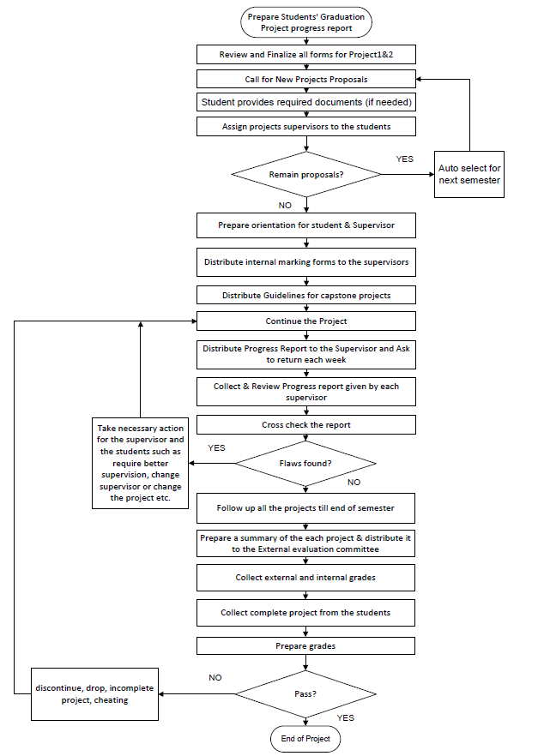

F. Learning Resources and Facilities

1.Learning Resources
Required Textbooks | Information Technology Project Management , Kathy Schwalbe, 7th edition, 2014.  Modern System Analysis & Design- Jeffrey Hpffer, Joey George, Joseph Valacich, 6th edition, Pearson  B.A. Forouzan, Data Communications and Networking, fourth edition, McGraw – Hill  Electronic Commerce 2010, A Managerial Perspective, Prentice Hall, (latest edition). Efraim Turban, Jae Lee, David King and Michel Chung  Ethical and Social Issues in the Information Age, Joseph M. Kizza Springer; 4th Edition, 2010  Harpreet Singh, (Implementing Cisco Networking Solutions: Configure, implement, and manage complex network designs 1st Edition, Kindle Edition), Packt Publishing, 2017.
Essential References Materials
Electronic Materials
Other Learning Materials

2. Facilities Required
Item | Resources
Accommodation  (Classrooms, laboratories, demonstration rooms/labs, etc.) | Project Lab
Technology Resources  (AV, data show, Smart Board, software, etc.) | Soft wares available in the labs’ computers
Other Resources  (Specify, e.g. if specific laboratory equipment is required, list requirements or attach a list) | Computer Networks Labs

G. Course Quality Evaluation
Evaluation  Areas/Issues | Evaluators | Evaluation Methods
Online Course Survey | Students | Indirects
Evaluation areas (e.g., Effectiveness of teaching and assessment, Extent of achievement of course learning outcomes, Quality of learning resources, etc.)
Evaluators (Students, Faculty, Program Leaders, Peer Reviewer, Others (specify)
Assessment Methods (Direct, Indirect)

H. Specification Approval Data
Council / Committee
Reference No.
Date

