College Annual Report.

For Computer Science and Information Systems Programs



**Najran University**

**Computer Science and Information System College**

**Table Of Contents**

|  |  |
| --- | --- |
| Heading | Page No |
| Introduction | 3 |
| About the College | 4 |
| College Vision | 6 |
| College Mission | 6 |
| College Strategic Objectives | 7 |
| Organizational Chart | 7 |
| College Council | 7 |
| Computer Science Department | 8 |
| Information System Department | 12 |
| Development and Quality Unit | 13 |
| Research Activities | 21 |
| Training and Workshops | 25 |
| Students Committee | 28 |
| Alumni Committee | 37 |
| Academic Advising | 38 |
| Community Service | 44 |
|  |  |

1. **Introduction**

All praise is due to Allah, and Allah’s Peace and Blessings be upon His Final Messenger, his pure family, his noble Companions, and all those who follow them with righteousness until the Day of Judgment.

People at all levels have become aware of the importance of computer and information technology and feel the great leap of civilization that the computer has introduced into the world. In a few years, many people have become aware of the Internet and this network of hundreds of millions of computers across the world has become a means of communicating and transmitting information between the world's vast and free destinations. Undoubtedly, these circulating materials contain different contents that constitute the culture of man and run the course of the civilization of societies.

Japan's Ministry of Industry and Commerce has identified computer and information technology as one of the three sciences that will determine the future of the world in the 21st century. In order for Saudi Arabia to be an active part of this digital world, it must participate in the manufacture and formation of its core tools. Hence the importance of the Faculty of Computer Science and Information Systems in the system of higher education in our country.

The College of Computer Science and Information Systems was established at the beginning of the academic year 1427, where the Department of Computer Science and Information Systems Department formed the first nucleus of the College. The College offers a number of programs in the field of computer and information technology to the local market industry and to keep up with the technological developments and achieve the requirements of higher education in our dear country.

1. **About the College**

College of computer science and information systems at Najran University was established on the eve of 2007 to meet the high demand of the market and keep abreast of current technological developments. Currently the college involves two departments, computer science and information systems offering programs in computer science and information systems respectively. Computer Science program aims to prepare students to become specialists in this vital area and award students a bachelor degree in computer science For the computer science program, the degree title for those students who satisfactorily complete the program is the bachelor of Computer Science. This is the only Bachelor degree offered by the program. The information systems department offers information systems program. The information systems program prepare students to fill the needs of the local labor market and also contribute to the development of scientific research in the Kingdom of Saudi Arabia. It is the only undergraduate program offered by the department at Najran University The study plans of the two programs have been very carefully framed to address the most recent development, and attention is dually given to both theory and practice. Besides the currently offered programs, a plan to expand its program offerings to include new programs such as computer engineering and networks at the bachelor level.

To account for the dynamic growth in the local market as well as the international advancements in the information resources fields, the college has endeavored to assure the quality of its academic program by taking a number of major decisions. In this respect, the college established a quality assurance unit which works cooperatively with the university rectorship of development and quality to establish and disseminate quality culture and practices in every aspects of academic programs. In a major step, the college has initiated ambitious goals to obtain academic accreditation for its academic programs form the National Commission for Assessment and Academic Accreditation and the worldwide recognized Accreditation Board for Engineering and Technology.

Motivated by the university and college missions, the college funds research projects and active research groups that are contributing quality research. These research groups have set and defined objectives to conduct research on various domains that includes data mining and artificial intelligence, software engineering, knowledge management, intelligent systems and robotics. Moreover, the college has provide excellent infrastructure in the form of building and space, library, computing facility with the help of a huge number of latest generation computers in a number of PC Labs, very fast accessible networks.

The college of computer science and information systems understands that it should cope with the rapid and continuous development in the Kingdom of Saudi Arabia in the last twenty years in the field of higher education and academic institutions. It also understands the importance of coping with the industry for both public and private sectors' demand in many areas and scientific disciplines (e.g. information technology). Therefore, the college forms an advisory board for each academic program in the college to get the valuable opinions of the community. Furthermore, the faculty members are always ready to provide valuable information to the community through meetings, discussions, workshops, orientation programs and newspaper articles.

1. **College Vision**

Leadership in computing education and researches and effective contribution to community development.

1. **College Mission**

The mission of the college of computer science and information systems is to

* Prepare high quality graduates through well-chosen and continuously developed programs.
* Conduct consistent high quality scientific research for the academic and community development.
* Provide high quality training and consultation services to meet the community needs.

1. **Strategic Objectives**

The strategic objectives of the college of computer science and information systems are

* Enhance the college's educational recognition at the national level.
* Prepare competent graduates to meet nation's needs.
* Reach national prominence in scientific research at the national level
* Strengthen the partnership with the community.

1. **Organizational Chart**

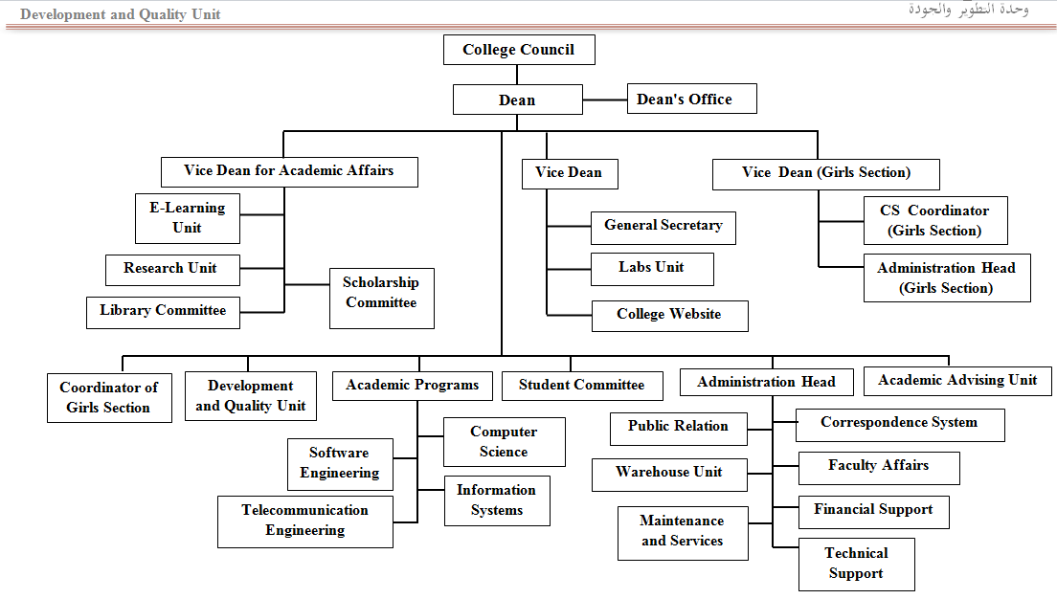

1. **College Council**

The college council members:

* Dr. Abdulla Ali Al Abass (Head)
* Dr. Mohammed Mfareh Assiri (Secretary)
* Dr. Abdullah Alwdie (Member)
* Dr. Khiran Dbash Rajab (Member)
* Dr. Abdulrahman Saad Al Thqfan (Member)
* Noora Abdulrahman Alshamrani (Member)

1. **Computer Science Department**

The Computer Science department of the College of computer science and information systems at Najran University was established on the eve of 2007 to meet the high demand of the market and keep abreast of current technological developments. Currently the department offers program in computer science. The Computer Science program aims to prepare students to become specialists in this vital area and award students a bachelor degree in computer science. The degree title for those students who satisfactorily complete the program is the bachelor of Computer Science. This is the only Bachelor degree offered by the program. The study plans of the computer science program has been very carefully framed to address the most recent development, and attention is dually given to both theory and practice.

Motivated by the university and college missions, the department funds research projects and active research groups that are contributing quality research. These research groups have set and defined objectives to conduct research on various domains that includes data mining and artificial intelligence, software engineering, knowledge management, intelligent systems and robotics. Moreover, the department has provide excellent infrastructure in the form of building and space, library, computing facility with the help of a huge number of latest generation computers in a number of PC Labs, very fast accessible networks.

**8.1 Department Council**

The Computer Science Department council members are:

* Dr. Abdulrahman Saad Al Thqfan (Head)
* Dr. Anwar Ali (Secretary)
* Dr. Addin Osman (Member)
* Dr. Khiran Dbash Rajab (Member)
* Ms. Dalal Alqahtani (Member)
* Ms. Somaya Alhazimi (Member)

The Department Council meets at least once every two weeks on the request of the Head of the Department. During the academic 1437/1438 the department council had 23 meetings to discuss various academic and administrative issues.

**8.2 Department Working Committees**

The computer science department council has decided in its 15th meeting to reform the current working committees in the department and form additional new committee to improve the performance of faculty members in achieving the department objectives. Each committee has specific tasks and in every semester, it must submit working plan, progress reports and final performance report to the department. The following Table shows the current working committees in the department with their specifications

|  |  |  |  |  |
| --- | --- | --- | --- | --- |
| **No.** | **Name** | **Head** | **Coordinators** | **Tasks** |
| 1 | Publicity Committee | Dr. Abdulrahman Althagfan | Mr. Naif Almudawi | * Gather, organize, and publish news about department activities on department websites. * Prepare and print brochures, manuals, handbooks … etc. * Update departments websites * Coordinates with college and departments website committees * Prepare and submit final performance report to the department |
| 2 | Examination Committee | Dr. Abdulrahman Althagfan | Dr. Addin Osman  Ms. Rania Zuhair | * Organize an supervise all activities related to examinations (midterms and final) in the department * Prepare examination budget * Prepare and submit final performance report to the department |
| 3 | Student advising committee | Dr. Abdulrahman Althagfan | Dr. Anwar Ali  Ms. Eman Abdulkareem | * facilitate academic advising for the current student * Organize meeting with the new students intakes * Prepare and submit final performance report to the department |
| 4 | Suggestions and complaints committee | Dr. Addin Osman | Dr. Anwar Ali  Ms. Nora Abdulaziz | * Study and follow up students suggestions * Deal with students complaints and take the necessary actions * Prepare and submit final performance report to the department |
| 5 | Students activities committee | Dr. Addin Osman | Mr. Hamad Abbosaq  Ms. Bashair Almansour | * Organize all students activities * Coordinate students activities with the deanship of students affairs * Prepare budget of students activities * Prepare and submit final performance report to the department |
| 6 | Development and quality committee | Dr. Abdulrahman Althagfan | Mr. Muhammad Akram | * Organize and supervise all department activities in development and academic accreditation * Coordinate with college unit of development and quality * Train new faculty member in various academic activities * Prepare and submit final performance report to the department |
| 7 | Translation and documentation committee | Dr. Abdulrahman Althagfan | Dr. Addin Osman | * Translate and update the content of the department English website * Translate department council resolutions * Translate department reports * Prepare and submit final performance report to the department |
| 8 | Timetable committee | Dr. Abdulrahman Althagfan | Dr. anwar Ali  Ms. Enaam Abdulqader | * Prepare timetable for all courses and faculty members * Submit lecturers teaching loads to the head of the department * Coordinate with the lecturers from other colleges * Prepare and submit final performance report to the department |
| 9 | Operational plan committee | Dr. Abdulrahman Althagfan | Dr. Addin Osman | * Improve the quality of the programs * Improve the academic advising system * Promote scientific research * Activate department working committee * Prepare and submit final performance report to the department |
| 10 | Lab and facilities committee | Dr. Abdulrahman Althagfan | Mr. Adlan Balola  Ms. Nazeema | * Supervise all lab related to the lab and * Prepare and submit final performance report to the department |
| 11 | Equivalency committee | Dr. Abdulrahman Althagfan | Dr. Addin Osman | * Handel all equivalency requests * Prepare and submit final performance report to the department |
| 12 | Teaching assistant and scholars committee | Dr. Abdulrahman Althagfan | Mr. Bakri Awagi | * Handling all affairs of teaching assistants and scholars * Prepare and submit final performance report to the department |
| 13 | Library and periodical committee | Dr. Abdulrahman Althagfan | Dr. anwar Ali  Ms. Aishah Abdulaziz | * Establish and supervise college library * Coordinate with the university deanship of libraries * Prepare and submit final performance report to the department |
| 14 | External courses committee | Dr. Abdulrahman Althagfan | Mr. Adlan Balolah  Ms. Nayla | * Supervise the external course * Coordinate with the other colleges * Prepare and submit final performance report to the department |
| 15 | Electronic Website committee | Dr. Abdulrahman Althagfan | Mr. Abdullah Almarie  Ms. Eman Abdulkareem | * Update and supervise department website * Prepare and submit final performance report to the department |
| 16 | Seminars and workshops committee | Dr. Abdulrahman Althagfan | Mr. Adlan Balolah  Ms. Munibah | * Organize training workshops * Implement training programs * Prepare and submit final performance report to the department |
| 17 | Community service committee | Dr. Abdulrahman Althagfan | Mr. Hatan Hassan  Ms. Suad Muhammad | * Organize and coordinate all activities directed to the community * Prepare and submit final performance report to the department |
| 18 | Alumni committee | Dr. Abdulrahman Althagfan | Mr. Adlan Balolah  Ms. Somaya Alhazimi | * Handling all Alumni affairs * Prepare and submit final performance report to the department |

Each of the above committee was requested to prepare work plan in which its objectives and actions to achieve them are stated. Based on the final report submitted to the head of the department, the performance of these committees are evaluated.

1. **Information Systems Department**

The major of information systems aims to provide students with the necessary knowledge for a career in the fields of Computer Information Systems (CIS) and programming project management, which involve the development and integration of multi-purpose systems. The importance of this major stems from the fact that development of systems builds on a combination of theory and practice, which have to be founded on sound background and methods in the fields dealing with IT. The department goals are

* + To establish a scientific, research-oriented environment that helps develop the knowledge and skills of the faculty of the department.
  + To encourage high-quality scientific research in the field of information systems.
  + To create qualitative and quantitative standards to assess the quality of the educational process and ensure the accomplishment of departmental goals.
  + To perform periodical assessment of departments and programs using global quality standards in order to obtain academic accreditation for the department.
  + To create an educational system that keeps pace with the continuous developments in the field of IT.

Currently the Information Systems program is offered by the department.

1. **Development and Quality Unit**

At the beginning of the academic year 2016-2017, the Development and Quality Unit (DQU) of the College of Computer Science and Information Systems-CSIS, has formed different committee and assigned tasks related to quality work. The tasks have been designed and distributed among the faculty members of both male and female sections of computer science-CS and information systems-IS Departments. In addition all the tasks have been assigned and distributed based on the basis of ABET and NCAAA criteria/ standards, requirements, priorities as listed in Table 1 and Table 2.

* 1. **Working Committees**

The following table presents the committees of the development and quality unit

|  |  |  |
| --- | --- | --- |
| Committee Name | Heads | Members |
| Development and Quality Unit (DQU) | Dr. Shargabi | 1) Dr. Abdur Rahman  2) Dr. Anwar Ali  3) Mr. Shah Masud  4) Mr. Mohammad Akram  5) Ms. Dalal Alqahtani  6) Ms. Nyla Khadam  7) Ms. Saira Banu |
| Assessment Committee  (AC-CS & AC-IS) | Dr. Shargabi | 1) Mr. Shah Masud (Coordinator)  2) Mr. Akram  3) Mr. Basit  4) Ms. Saira Banu  5) Dr. Muniba |
| Curriculum Committee-CS  (CC-CS) | Dr. Abdur Rahman | 1) Dr. Anwar Ali (coordinator)  2) Dr. Addin  3) Dr. Khairan  4) Mr. Salim  5) Ms. Dalal Alqahtani  6) Ms. Nyla Khadam  7) Dr. Muniba |
| Curriculum Committee-IS  (CC-IS) | Dr. Ghassan | 1) Mr. Shah Masud (Coordinator)  2) Dr. Shargabi  3) Dr. Asadullah  4) Dr. Fikri  5) Mr. Basit |
| Facilities and Resources Committee  (FRC-CS & FRC-IS) | Mr. Shah Masud | 1) Mr. Adlan Balola (Coordinator)  2) Mr. Gulam Faruq  3) Mr. Salim  4) Mr. Haji  5) Mr. Nayef  6) Mr. Sultan Al Azmi  7) Mr. Hattan  8) Ms. Saira  9) Ms. Gulshan Aara  10) Ms.Raniah Zaheer  11) Ms. Zehra Alwadie  12) Ms. Morady Mohammad  13) Ms. Nazeema Parveen |
| Program Students Affairs Committee  (PSAC-CS & PSC-IS) | Dr. Ghassan | 1) Mr. Basit (Coordinator)  2) Mr. Adlan  3) Mr. Salim  4) Mr. Omar  5) Mr. Zamanan  6) Mr. Abdullah Marih  7) Mr. Faris  8) Mr. Hattan  9) Ms. Enaam AbdQader  10) Ms. Raniah  11) Dr. Muniba  12) Ms. Emaan Abdel Kareem  13) Ms. Bashair AlMansour,  14) Ms. Feryal Mohammad  15) Ms.Ghada Alsarhani |
| Faculty Affairs Committee  (FAC-CS & FAC-IS) | Dr. Khairan | 1) Dr. Shargabi (Coordinator)  2) Dr. Fekri  3) Mr. Golam Faruque  4) Mr. Khalid Makdi  5) Mr. Bakri  6) Mr. Moad  7) Ms. Emaan AbdelKareem  8) Ms. Enaam AbdelQader  9) Ms. Gulshan Aara  10) Ms. Awatif Mohammad  11) Ms.Enaam AbdelQader  12) Ms. Soad  13) Ms. Amal Saeed |
| Research and Community Service Committee (RCC-CS & RCC-IS) | Dr. Khairan | 1) Dr. Asadullah (Coordinator)  2) Dr. Khairi  3) Mr. Akram  4) Mr. Golam Faruque  5) Mr. Nayef  6) Mr. Hamad Abusaq  7) Ms. Summaiyya Alhazmi  8) Ms. Nazeema Parveen  9) Ms. Soad  10) Ms. Dalal Alqahtani  11) Ms. Sahar Saeed |
| Archive and Translation Committee (ATC) | Dr. Asadullah | 1) Mr. Mazen (Coordinator)  2) Mr. Omar Abdurrahman  3) Mr. Salim  4) Mr. Khalid Al Makhdi  5) Mr. Hamad Abosaq  6) Mr. Saeed Saad  7) Ms. Saod Mohammed  8) Ms. Enaam AbdelQader  9) Ms. Summaiya Alhazmi |

The following table presents the distribution of ABET and NCAAA requirements on the Committees

|  |  |  |  |  |
| --- | --- | --- | --- | --- |
| **Committee**  **Name** | **ABET Criteria** | **NCAAA Standards for the CS & IS Programs** | **University Strategic Projects** | **Expected Activities: each committee is expected to do the following:** |
| DQU | Criterion 2: Program Educational Objectives (CS & IS)    Criterion 3: Student Outcomes (CS & IS) | ST 1: Mission and Objectives  ST 3: Management of Quality Assurance and Improvement |  | • Full revision of the ABET criteria and NCAAA Standards  • Collect Data about KPIs  • KPIs analysis report report that should contain a list of strengths, weaknesses and recommendations for improvement, and priorities for action.  • Update evidences if required  • All mechanisms related to the standards must be implemented  • Update NCAAA SES  • Internal benchmarking is important to compare the old results of KPIs with the current results.  • The requirements of the university deanship's of quality must be considered in our work.  • Final report with all evidences must be prepared for each one of the university strategic project |
| Heads of Departments (CS and IS) |  | ST 2: Governance and Administration |  |
| Assessment Committee (AC-CS & AC-IS) | Criterion 4: Continuous Improvement (CS & IS) | ST 4: Learning and Teaching |  |
| Curriculum Committee  (CC-CS & CC-IS) | Criterion 5: Curriculum (CS & IS) | ST 4: Learning and Teaching | Project Code 1/3: Development of curriculum if needed |
| Program Students Affairs Committee  (PSAC-CS & PSAC-IS) | Criterion 1: Students (CS & IS) | ST 5: Student Administration and Support Services |  |
| Facilities and Resources Committee (FRC-CS & FRC-IS) | Criterion 7: Facilities (CS & IS) | ST 6: Facilities and Equipment  ST 7: Learning Resources |  |
| Faculty Committee Affairs (FAC-CS & FC-IS) | Criterion 6: Faculty (CS & IS) | ST 8: Employment Processes  ST 9: Financial Planning and Management | Project Code: 3/6 Evaluation (Quantitative and Qualitative) of the current academic organizational chart according to the requirements of the program |
| Research and Community Service Committee (RCC-CS & RCC-IS) | Criterion 8: Institutional Support (CS & IS) | ST 10: Research  ST 11: Institutional Relationships With the Community | Project Code 1/4: Establishment of new programs according the community and labors market needs. |
| Archive and Translation Committee (ATC) | This committee (ATC) will serve all committees in the college. More specifically, ATC will collect evidences (Soft and Hard Copies) from other committees and organize them in a way that could be easily accessible by the faculty. They are also responsible to translate documents from Arabic to English and vice versa. | | | |

At the end of academic year 2016-2017 it has been revealed that the DQU of the College of CSIS has achieved the following 30 tasks:

* + - * Preparing CS NCAAA Accreditation Visit Documents in August 2016
      * Preparing CS program learning outcomes-PLOs or SOs Assessment Plan 2017-2021
      * Preparing IS program learning outcomes-PLOs or SOs Assessment Plan 2017-2021
      * Reviewing and finalizing the self evaluation scale-SES for CS Program
      * Reviewing and finalizing the self evaluation scale-SES for IS Program
      * Design a systemic Rubric in excel to assess SES of different NCAAA standard
      * Participate in Reviewing the IS Curriculum
      * Participating in the meetings and contributed in developing Network and Communication Engineering (NCE) Program’s Study Plan
* Reviewing, assessing and analyzing the KPIs of CS Program
* Reviewing, assessing and analyzing the KPIs of IS Program
* Reviewing, updating, and preparing ABET CS Program SSR
* Reviewing, updating, and preparing ABET IS Program SSR
* Reviewing, updating, and preparing NCAAA SSR for CS Program
* Formulate a working committee and started preparing NCAAA SSR for IS Program
* Prepare semester wise overall course report for IS Program
* Prepare semester wise overall course report for CS Program
* Prepare CS Program report
* Prepare IS Program report
* Nominate Course coordinators and followed up exam question moderation process
* Supervise course file submission procedures and related issues
* Following up semester wise course distribution among the faculty members
* Updating some issues in [NUCSIS.info](http://nucsis.info/) System including Academic Advising and followed up academic advising process
* Following up the working forces and services and facilities of internal exam committee-IEC and external exam committee-EEC, and initialize and distribute invigilators regulations and duties during final examinations
* Participate in Reviewing Summer training and Graduation Project issues
* Prepare the CS program NCAAA Institutional Visit Reports
* Prepare the IS program NCAAA Institutional Visit Reports
* Conducting meeting with program advisory committee-PAC
* Updating the Faculty unified survey and uploaded on Survey Monkey
* Preparing various survey-questionnaires for faculty and students
* Conducting various meetings related to teaching and quality and continuous quality improvement process
  1. **Role of DQU in study plan for IS curriculum:**

The coordinator of DQU Dr. Mohammed AbdulLatif Shargabi, attended one such meeting and emphasized that curriculum changes have to discussed based on some criteria, the curriculum should have to meet some requirements such as:

* The program should meet and related to the mission, vision of the university
* University Requirements courses ( eg: Islamic courses ) have to included. The new requirement of the University like field training etc.
* College requirement courses such as (programming, data structures, and operating system) have to be included.
* IS environmental courses should meet a minimum criteria
* The other criteria is that the program should have included to contain minimum credits/courses related to different knowledge domains such as, Networking, Programming, Information Management, Database, Basic Science including mathematics etc.
* The IS curriculum committee held subsequent meeting throughout the month of March, April and May to further discuss, improve and update the study plan according to requirements.
* The DQU coordinator has been regularly attending the meeting held in IS program and giving his inputs in the curriculum update.
* By the time of preparation of this report the IS program has been working on the curriculum update.
  1. **Participated in the meetings and contributed in developing Network and Communication Engineering (NCE) Program’s Study Plan**

Najran University has approved to start new bachelor program in college of Computer Science and Information Systems (CCSIS) with title: Computer Networks and Communication Engineering Program. A committee was formed in May 2016 under the supervision of college’s Development and Quality Unit (DQU) to design the curriculum for new program. Since one year this committee meets several times to discuss the study plan for new program. Moreover study plan is still under discussion and is not finalized yet.

**Committee members:**

The first committee has been formed by the following members in May 16, 2016:

* + Dr. Khairan Rajab
  + Dr. Mohammed Al Shargabi
  + Dr. Ahmad Taleb
  + Dr. Addin Osman
  + Dr. Ghassan Ahmad Ali
  + Mr. Shah Murtaza Rashid Al Masud
  + Mr. Haji Moin Uddin
  + Mr. Samiul Islam
  + Mr. Monjurul Hasan
  + Mrs. Nayla Khadem

At the end of 2016, the committee has been reformed because some of the faculty members left the college in the academic year of 2015-2016. The revised committee members are:

* + Dr. Khairan Rajab
  + Dr. Mohammed Al Shargabi
  + Dr. Ghassan Ahmad Ali
  + Mr. Shah Murtaza Rashid Al Masud
  + Mr. Haji Moin Uddin
  + Mr. Muhammad Akram
  + Mrs. Nyla Khadam
  + Mr. Mohammad Al Awashiz
  + Mr. Hamad Abosaq

Key activities: finalizing mission statement of the program, student outcomes, and knowledge group, preparing the study plan, finalizing the curriculum.

1. **Research Activities**

Najran University is a growing university in research activities, with an active research curriculum, enhancing the academic standing of the institution as a channel of higher learning. Currently, we have funded research projects and active research groups. These research groups are responsible to conduct the quality of research for the department of computer science and information system of Najran University. This plan will reinforce this vision for research as an integral part of the University’s academic activity in the future. The ten Key objectives of this Plan are:

* + - * Ensure that computer science programs (CS & IS) makes a significant contribution to the Research Excellence Framework 2017, either through the University Research Deanship or through their other research activities, and with the support of the University’s professional services.
      * Apply for the research grant at deanship of research for the session of 2017-2018 and achieve quality of outputs, environment and impact, as judged against our benchmarks in Sub-standard given in the table below.
      * Increase our total research income – deanship of research + externally funded research – to achieve total output for KPIs by 2017.
      * Apply King Abdulaziz City for Science and Technology (KACST) research grant to enhance the research activities in the department. Since there is no adequate funding for departmental research, therefore, KACST is the only source to carry out the research activities. At least one proposal will be submitted by each group. The current working groups in our department are:
  + **Data Mining and Artificial Intelligence**

Dr. Anwar

Miss Muniba Memon

Mr. Yahiya

Mr Gholam Faroque

* **Intelligent System and Robotics (ISR)**

Dr. Zakariya Saeed

Dr. Abdul Lateef Shargabi

Mr. Muhammad Zamannan

* + - * Review this plan to ensure the continued promotion and development of research from August 2017 onwards (using the outcomes of the KACST research grant and deanship of research).
      * Continue to invest strategically to support research activities with a research active curriculum, systematically encouraging academic enquiry and knowledge creation across the University.

The following Table presents the list List of Publication for Quality Development 2016-2017

|  |  |  |  |  |  |
| --- | --- | --- | --- | --- | --- |
| **No** | Paper | **Year** | **Status** | **Faculty Member** | **Department** |
|  | Mohammad Alsulami and Asadullah Shaikh. The Information-Seeking Problem in Human-Technology Interaction. International Journal of Advanced Computer Science and Applications(ijacsa), 7(5), 2016. Impact Factor 1.32, 2016 [[PDF](https://thesai.org/Downloads/Volume7No5/Paper_77-The_Information_Seeking_Problem.pdf)]. | 2016 | published | Dr. Asadullah Shaikh | Information Systems |
|  | Asadullah Shaikh and Uffe Kock Wiil. Efficient Verification-Driven Slicing of UML/OCL Class Diagrams. International Journal of Advanced Computer Science and Applications(ijacsa), 7(5), 2016. Impact Factor 1.32, 2016 [[PDF](https://thesai.org/Downloads/Volume7No5/Paper_71-Efficient_Verification_Driven_Slicing.pdf)]. | 2016 | Published | Dr. Asadullah Shaikh | Information Systems |
|  | Muhammad Ali Memon, Asadullah Shaikh, Khizer Hayat and Mutiullah Shaikh. Virtual Heterogeneous Model Integration Layer. International Journal of Advanced Computer Science and Applications(ijacsa), 7(5), 2016. Impact Factor 1.32, 2016 [[PDF](http://thesai.org/Downloads/Volume7No5/Paper_78-Virtual_Heterogeneous_Model_Integration_Layer.pdf)]. | 2016 | published | Dr. Asadullah Shaikh | Information Systems |
|  | Mutiullah Shaikh, Asadullah Shaikh, Muhammad Ali Memon and Farah Deeba. Analyzing Virtual Machine Live Migration in Application Data Context. International Journal of Advanced Computer Science and Applications(ijacsa), 7(5), 2016. Impact Factor 1.32, 2016 [[PDF](https://thesai.org/Downloads/Volume7No5/Paper_54-Analyzing_Virtual_Machine_Live_Migration_in_Application_Data_Context.pdf)]. | 2016 | published | Dr. Asadullah Shaikh | Information Systems |
| 5 | Ahmad Taleb, Shah Murtaza Rashid Al Masud, Mohammed Al Shargabi, ‘Developing a Quality Assurance System using NCAAA and ABET Accreditation Standards: College of Computer Science and Information Systems, Najran University-Case Study’, accepted paper for the 1st national computing colleges conference-NCCC-2016, king abdulaziz university, Jeddah, KSA, February 17-18, 2016 | 2016 | Published | Shah Murtaza Rashid Al Masud | Information Systems |
| 6 | Shah Murtaza Rashid Al Masud, ‘Towards Designing of a Hajj Healthcare System Employing Wireless Body Area Network and Wireless Mesh Network’; submitted paper for ‘2016 International Conference on Computer Systems and Informatics (ICCSI 2016)’, Taif University, Taif, KSA, May 3-5, 2016 | 2016 | Published | Shah Murtaza Rashid Al Masud | Information Systems |
| 7 | Mohammad Arif Siddiqui, Shah Murtaza Rashid Al Masud, Mohammed Basit Kamal, ‘[Towards Improving the Quality of Present MAC Protocols for LECIM Systems’](http://thesai.org/Downloads/Volume7No6/Paper_36-Towards_Improving_the_Quality_of_Present_MAC_Protocols.pdf) International Journal of Advanced Computer Science and Applications(ijacsa), 7(6), 2016, Thomson Reuters (ISI), Impact Factor 1.32 | 2016 | Published | Shah Murtaza Rashid Al Masud | Information Systems |
| 8 | Mohamed A. Khairi, Ph.D., Gholam Ali Shaykhian, Ph.D.,Jinan Ziade , PH.D. Architectural evaluation of Master Data Management (MDM).2016 ASEE Annual Conference papers (2016), New Orleans, Louisiana , USA | 2016 | published | DR. Mohamed A. Khairi | Information Systems |
| 9 | Jinan Ziade , PH.D., Mohamed A. Khairi, Ph.D., Gholam Ali Shaykhian, Ph.D., How Cultural Understanding Influences Business Success in Middle East and North Africa (MENA). 2016 ASEE Annual Conference papers (2016), New Orleans, Louisiana , USA | 2016 | published | Dr. Mohamed A. Khairi | Information Systems |
| 10 | Dr. Mohamed Khairi, Adlan Balola Ali. Factors affecting Information Technology Students’ motivation; Case Study: Najran University, Saudi Arabia. GJHSS-G Volume 16 Issue 5 Version 1.0 | 2016 | published | Dr. Mohamed Khairi | Information system |
| 11 | Omar A. Ali, Talaat M. Wahbi, Izzeldin M. Osman. E-government Security Models. International Journal of Computer Applications Technology and Research. Volume 5– Issue 7, 439 - 442, 2016 | 2016 | Published | Omar Abdul rahman | Information Systems |
| 12 | Omar A. Ali, Talaat M. Wahbi, Izzeldin M. Osman. Design and Implementation Security Model for Sudanese E-government. International Journal of Computer Applications Technology and Research. Volume 5 issue 7, 443 – 447, 2016 | 2016 | Published | Omar Abdul Rahman | Information Systems |
| 13 | Towards Improving the Quality of Present MAC Protocols for LECIM Systems - See more at: (<http://thesai.org/Publications/ViewPaper?Volume=7&Issue=6&Code=IJACSA&SerialNo=36#sthash.EwwxHnlq.dpuf>.IJACSA) International Journal of Advanced Computer Science and Applications, Vol. 7, No. 6, 2016.Thompson reuters (ISI) Impact factor 1.32 | 2016 | Published | Mohammed Basit Kamal | Information Systems |
| 14 | [Social Computing: The Impact on Cultural Behavior](http://thesai.org/Downloads/Volume7No7/Paper_32-Social_Computing_the_Impact_on_Cultural_Behavior.pdf). International Journal of Advanced Computer Science and Applications (ijacsa), Volume 7 Issue 7, 2016. Digital Object Identifier (DOI) : [10.14569/IJACSA.2016.070732](http://dx.doi.org/10.14569/IJACSA.2016.070732)I | 2016 | Published | Naif Ali Almudawi | Computer Science |
| 15 | [Cloud Computing Privacy Concerns in Social Networks - International Journal of Computer (IJC).](http://www.ijcjournal.org/index.php/InternationalJournalOfComputer/article/view/673) Vol 22, No 1 (2016) | 2016 | Published | Naif Ali Almudawi | Computer Science |
| 16 | Soobia Saeed, Asadullah Shaikh and Shahbaz Ahmed Noor. Analysis of Brain Tumor Due To the Usage of Mobile Phone. Accepted in Mehran University Research Journal of Engineering & Technology, HEC Recognized, 2017. | 2017 | Accepted | Dr. Asadullah Shaikh | Information Systems |
| 17 | Soobia Saeed, Asadullah Shaikh and Syed Mehmood Raza Naqvi. Performance Analysis of Quality Assurance due to the usage of two Enterprise Resource Planning’s (ERPs): Microsoft Dynamics AX and SAP. Accepted in Mehran University Research Journal of Engineering & Technology, HEC Recognized, 2017. | 2017 | Accepted | Dr. Asadullah Shaikh | Information Systems |
| 18. | Addin Osman, Web-Accessibility Automatic Checking Tools and Evaluation in Saudi Arabia: A Systematic Literature Review, International Journal of Engineering Science and Innovative Technology (IJESIT), Impact Factor 1.913 | 2017 | Accepted | Dr. Addin Osman | Computer Science |
| 19. | Anwar Ali Yahya, Addin Osman and Mohammad Said El-Bashir, Rocchio algorithm-based particle initialization mechanism for effective PSO classification of high dimensional data, [Swarm and Evolutionary Computation](http://www.sciencedirect.com/science/journal/22106502) – ELSEVIER (Web of Science-ISI), Impact Factor: 2.963 Five Years Impact Factor: 5.77 | 2016 | Accepted | Dr. Addin Osman | Computer Science |
| 20. | Mining educational data to analyze teaching effectiveness, Journal of Theoretical and Applied Information Technology, 2016 | 2016 | Accepted | Dr. Addin Osman | Computer Science |
| 21 | Anwar Ali Yahya, Addin Osman and Mohammad Said El-Bashir, Rocchio algorithm-based particle initialization mechanism for effective PSO classification of high dimensional data, [Swarm and Evolutionary Computation](http://www.sciencedirect.com/science/journal/22106502) – ELSEVIER (Web of Science-ISI), Impact Factor: 2.963 Five Years Impact Factor: 5.77 | 2016 | Published | Dr. Anwar Ali Yahya | Computer Science |
| 22 | Mining educational data to analyze teaching effectiveness, Journal of Theoretical and Applied Information Technology, 2016 | 2016 | Published | Dr. Anwar Ali Yahya | Computer Science |
| 23 | I. F. ZAMAMI, M. MEMON. Establishing model of Mobile government services at Saudi Arabia. Published in Sindh University Research Journal (Science Series) (SURJ), Vol 48, No 4D (2016), ISI indexed. [pdf](http://sujo.usindh.edu.pk/index.php/SURJ/article/view/2736/2156) | 2016 | Published | Dr. Muniba Memon | Computer Science |
| 24 | Dr. Muniba Memon, Ikhlas Zamzami, Yaqoob Koondhar. Twitter Sentiment Analysis and Clustering of Crisis Events. Accepted in Asian Journal, ISI Indexed. | 2017 | Accepted | Dr. Muniba Memon | Computer Science |
| 25 | *A. WAQAS, A. R. GILAL, M. MEMON, H.A. M. MALIK, M. KARBASI, B. R. MEMON.* Modeling and Analysis of Search Interests for Viral Videos in YouTube: A Case Study. Published in Sindh University Research Journal (Science Series) (SURJ), Vol 48, No. 2 (2016), ISI indexed. [pdf](http://sujo.usindh.edu.pk/index.php/SURJ/article/view/2382/2032) | 2016 | Published | Dr. Muniba Memon | Computer Science |

1. **Training and Workshops**

The importance and effectiveness of faculty training programs to enhance and elevate faculty members' professional abilities in teaching are well-known fact. Some institutions mandate in-service training for all faculty members; others require certificates in teaching. Furthermore, faculty professional development should be looked at as a lifelong learning process. The faculty-training programs is essential for the improvement of teachers' skills, the development of teachers' conceptions of teaching and learning, and the consequent changes in students' learning.

Faculty members' competency encompasses knowledge of subject matter, teaching skills and professional attitudes. Obviously, knowledge based on a subject matter is not enough to claim competency in teaching. Besides subject matter, teaching professional competency requires additional "nonacademic" knowledge (i.e. social, administrative and technical). In fact, learning strategies, learning to learn and reflecting on these learning strategies (meta-cognition) are as important as mastering content. Furthermore, the report referenced the work of Darling-Hammond who listed a number of studies “indicating that pedagogical training generally has a stronger effect than subject matter mastery".

Realizing the key role of the training programs for effective teaching and achievement of the intended learning outcomes, the deanship of the development and quality of Najran University offers a complete training program, which consists of a number of training workshops that cover various aspects of teaching and research. The program announced at the beginning of each semester of the academic year and they regularly send invitations of conducted workshops to the colleges. Based on their needs and plans, the colleges nominate candidates for attending the workshops.

The following figure is a summary of the Attended DDQ Workshops (Male Section)

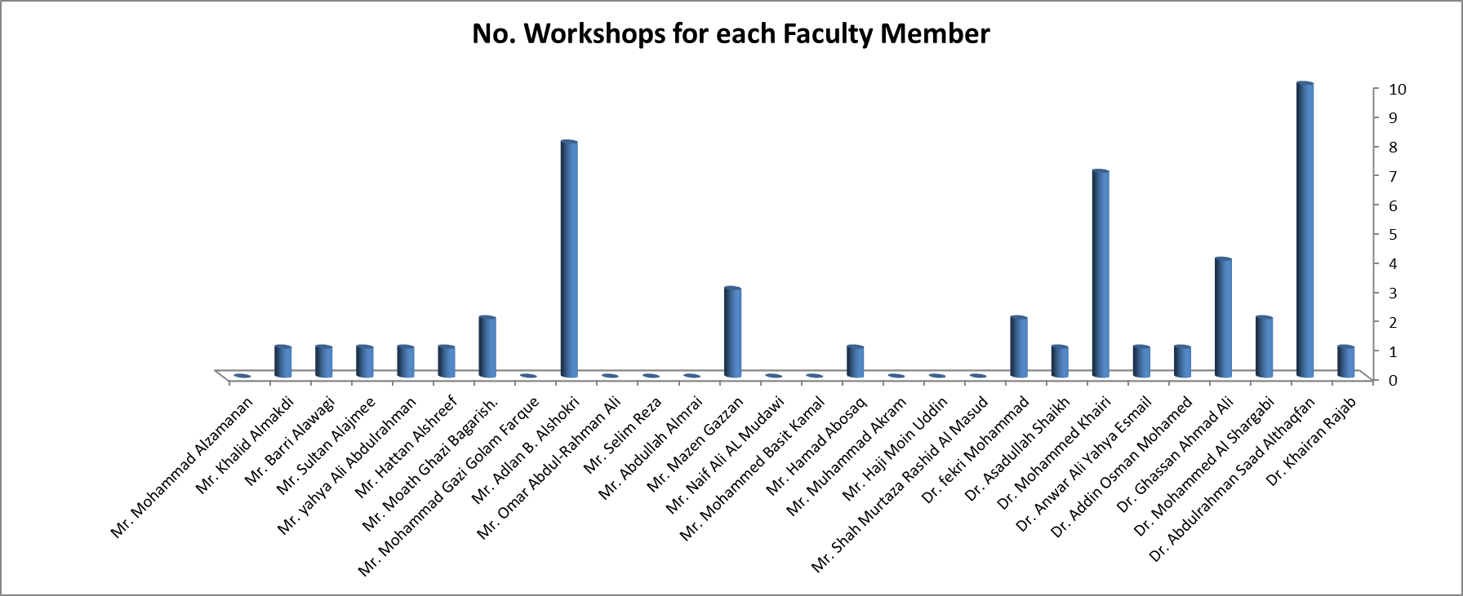

The following figure is a summary of the Attended DDQ Workshops (Female Section)

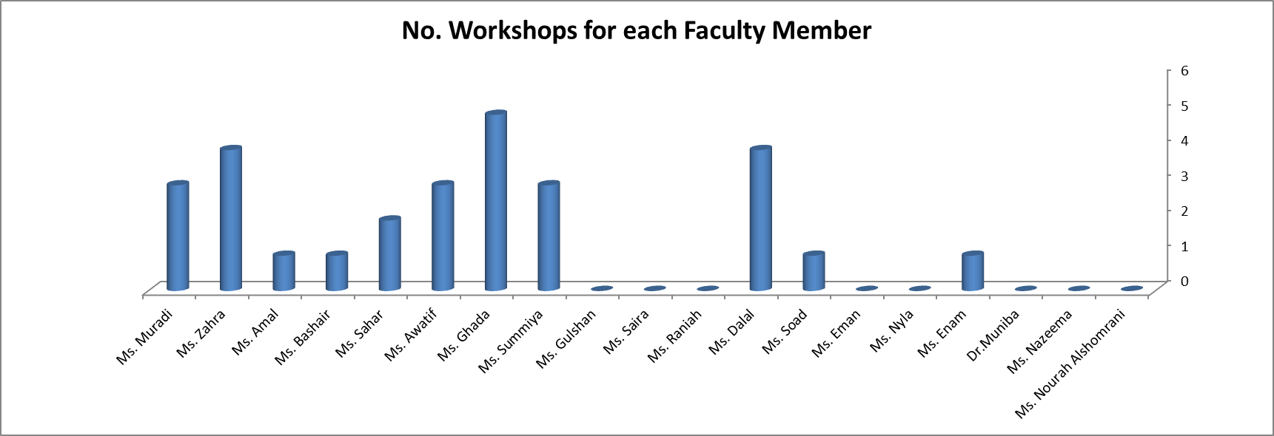

1. **Students Committee**

Extracurricular activities are a vital role of students experience at the college of Computer Science and Information System, in which it creates unique opportunities for friendship and learning new practices. College of Computer Science and Information System hosts plenty of activities throughout the term that celebrate campus ethnic and cultural diversity. The main goal of extracurricular activities concentrate on the individual student level , the institutional level , and the border community level. Through our college activities, students will be able to develop skills related to their career path and imperative for future job success. Students also will have the opportunities to improve their leadership and interpersonal skills while increasing their self-confidence as well. The involvement of extracurricular makes students link their academic knowledge with practical experience through leading to a better understating of their own abilities, talents, and professional goals.

* 1. **Vision of Student Activity**

Promote the faculty through its excellence in various student activities, in order to achieve a leading position among the faculties of the university, as well as other universities.

* 1. **Mission of Student Activity**

Developing students' skills by practicing various student activities and instilling in them concepts and ethical values that help them practice their work in practice.

* 1. **Objectives**

Contribute to the integrated preparation of students culturally, socially and scientifically and deepen some of their social values.

* 1. **Activities**

The following is a list of activities performed by the college in 1437/1438 (2016/2017)

* + 1. **Cultural Activity**

|  |  |  |
| --- | --- | --- |
| Coordinator | Computer Science and Information System | **College** |
| Dr. Abdulrahman Saad  Dr. Gassan Ahmed  Mr. Mohammed Zamanan | New Student Orientation | **Activity Title** |
| Tuesday, 14 February , 2017 | **Date** |

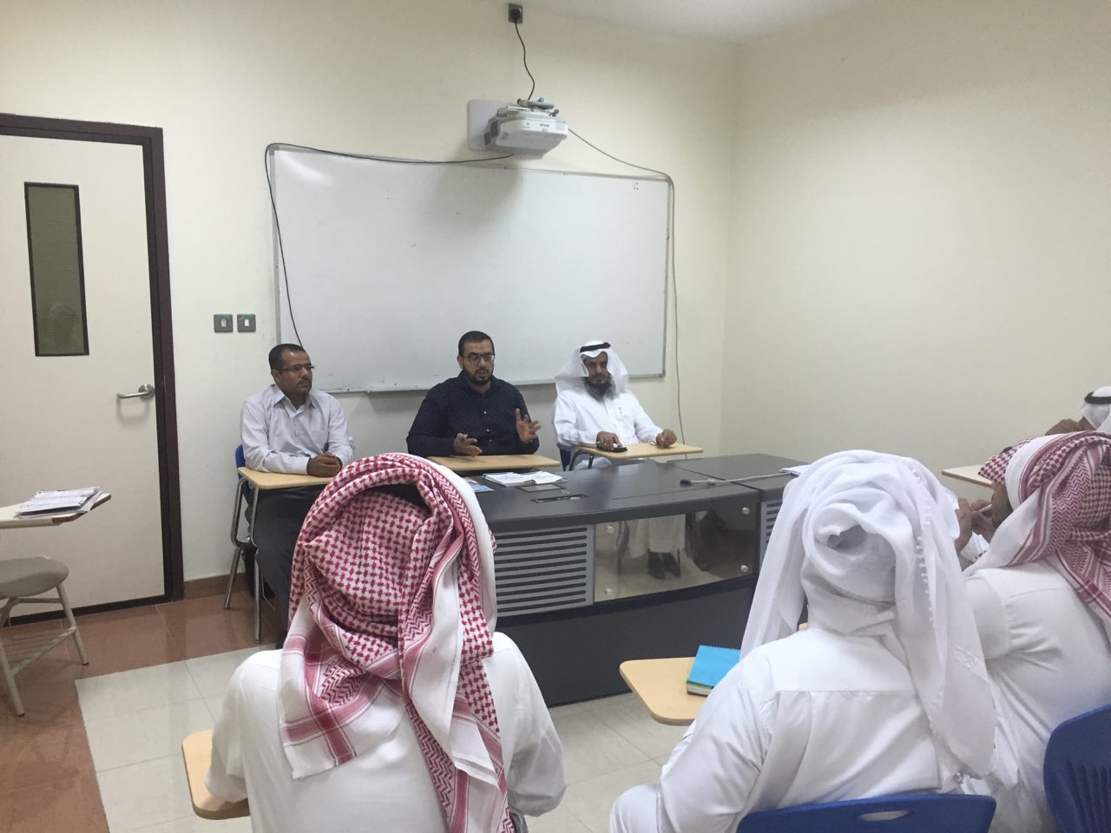

|  |  |  |
| --- | --- | --- |
| Coordinator | Computer Science and Information System | **College** |
| Mr. Mohammed Zamanan | Lecture In Modern Topics In Computer  Science | **Activity Title** |
| Wednesday, 23 November, 2016 | **Date** |

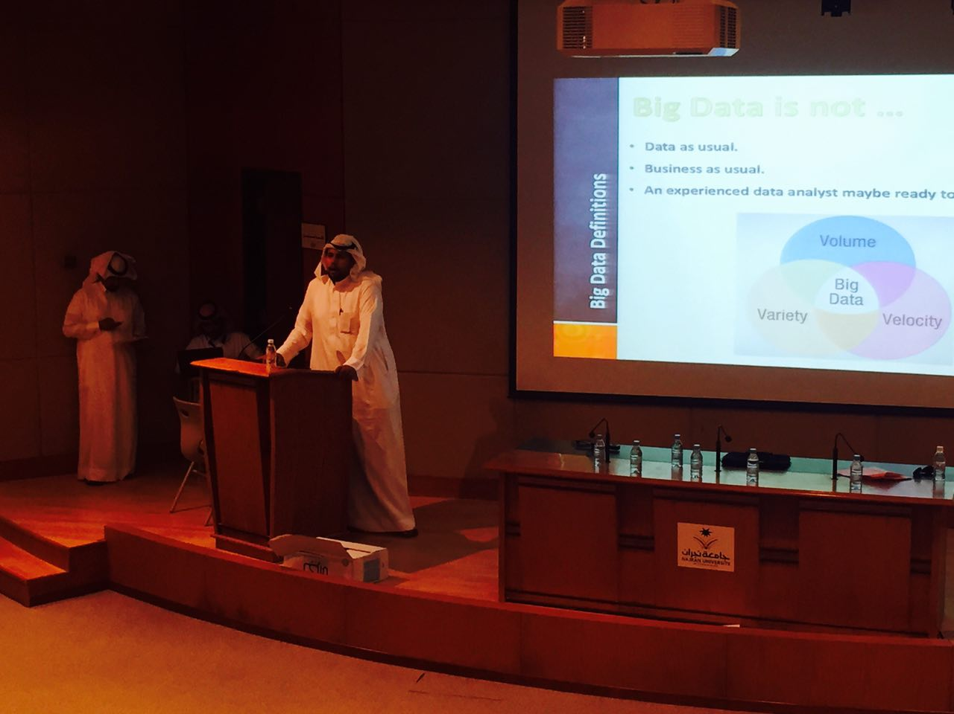

|  |  |  |
| --- | --- | --- |
| Coordinator | Computer Science and Information System | **College** |
| Mr. Mohammed Zamanan  Mr. Adlan Ahmad | Lecture In The Proper Use of Digital Library | **Activity Title** |
| Monday, 17 October, 2016 | **Date** |

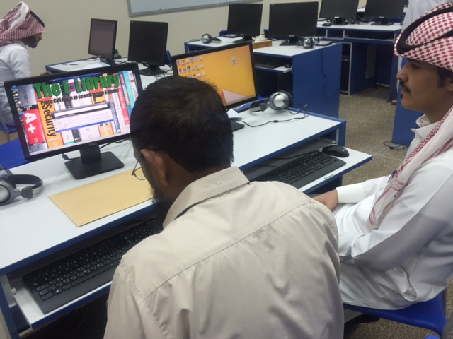

|  |  |  |
| --- | --- | --- |
| Coordinator | Computer Science and Information System | **College** |
| Dr. Asadallah  Mr. Mohammed Zamanan  Mr. Mazen Gassen  Mr. Bakri Awji | Lecture In How To Write Your Resume and Prepare For Job Interviews | **Activity Title** |
| Sunday, 04 December, 2016 | **Date** |

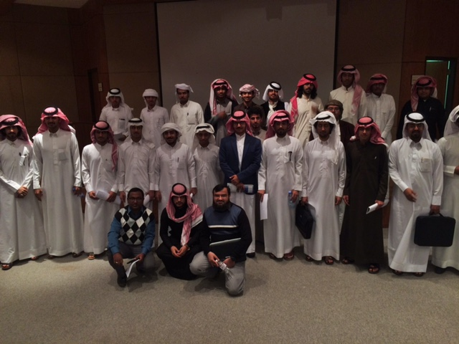

* + 1. **Social Activity**

|  |  |  |
| --- | --- | --- |
| Coordinator | Computer Science and Information System | **College** |
| Dr. Abdullah Alabas | Open Speech of the College’s Dean with Students | **Activity Title** |
| Wednesday, 21 September, 2016 | **Date** |

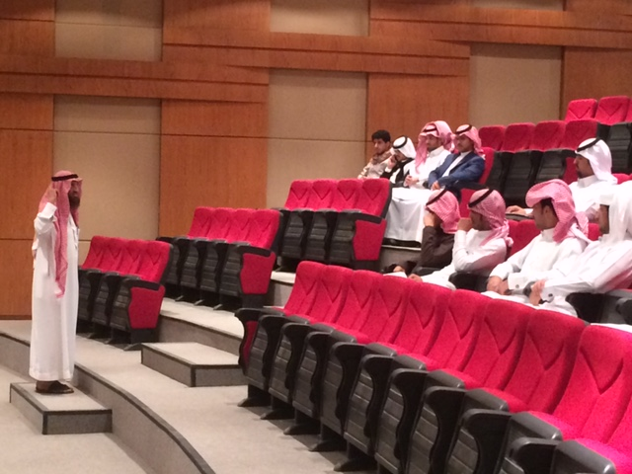

|  |  |  |
| --- | --- | --- |
| Coordinator | Computer Science and Information System | **College** |
| Mr. Mohammed Zamanan | Student Council Meet | **Activity Title** |
| Sunday, 26 March, 2017 | **Date** |

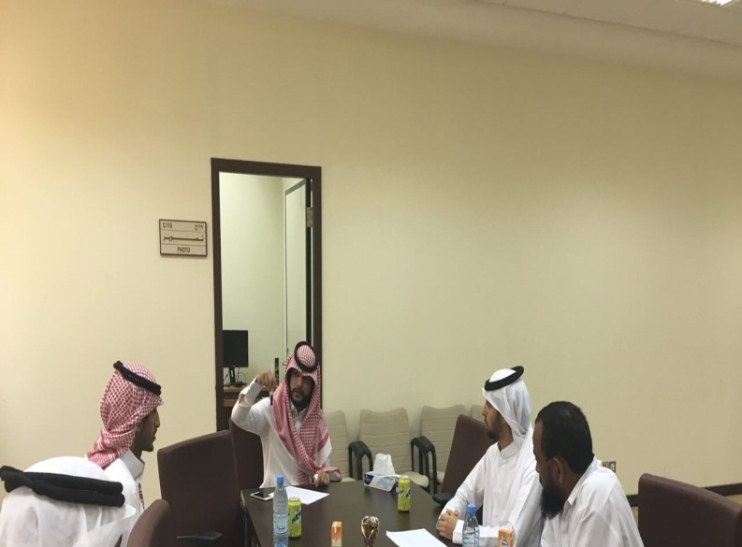

* + 1. **Sports Activity**

|  |  |  |
| --- | --- | --- |
| Coordinator | Computer Science and Information System | College |
| Mr. Mohammed Zamanan | College League Match | Activity Title |
| Sunday, 26 March, 2017 | Date |

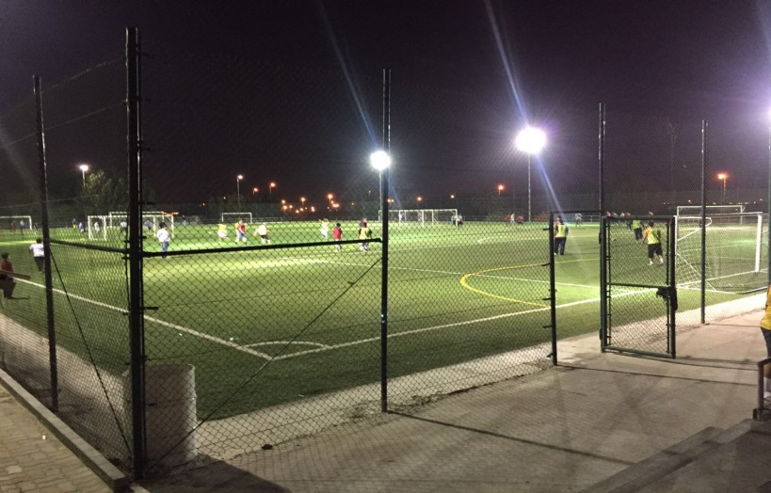

|  |  |  |
| --- | --- | --- |
| Coordinator | Computer Science and Information System | College |
| Mr. Mohammed Zamanan | Volleyball Match | Activity Title |
| Friday, 16 September, 2016 | Date |

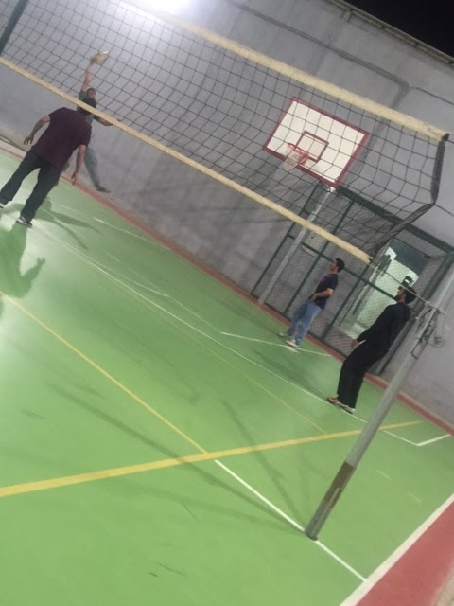

|  |  |  |
| --- | --- | --- |
| Coordinator | Computer Science and Information System | **College** |
| Mr. Mohammed Zamanan | Final Soccer Match on Rector NU Cup | **Activity Title** |
| Friday, 14 April, 2017 | **Date** |

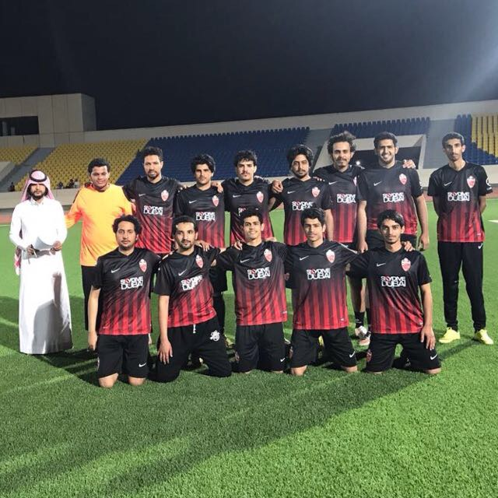

* + 1. **Academic Activity**

|  |  |  |
| --- | --- | --- |
| Coordinator | Computer Science and Information System | **College** |
| Mr. Mohammed Zamanan | Students’ Participation in Building A Data Archiving System for Najran Municipality | **Activity Title** |
|

|  |  |  |
| --- | --- | --- |
| Coordinator | Computer Science and Information System | **College** |
| Mr. Mohammed Zamanan | Students’ Participation in Building A Parking System for Najran University | **Activity Title** |
|

* + 1. **Student Skills Competition**

|  |  |  |
| --- | --- | --- |
| **Coordinator** | Computer Science and Information System | **College** |
| Dr. Abdullah Alabas  Dr. Khairan Rajab  Dr. Mohammed Alshargabi  Dr. Mohammed Khairi  Dr. Asadallah | Students’ Participation in The National Computing Colleges Conference | **Activity Title** |
|

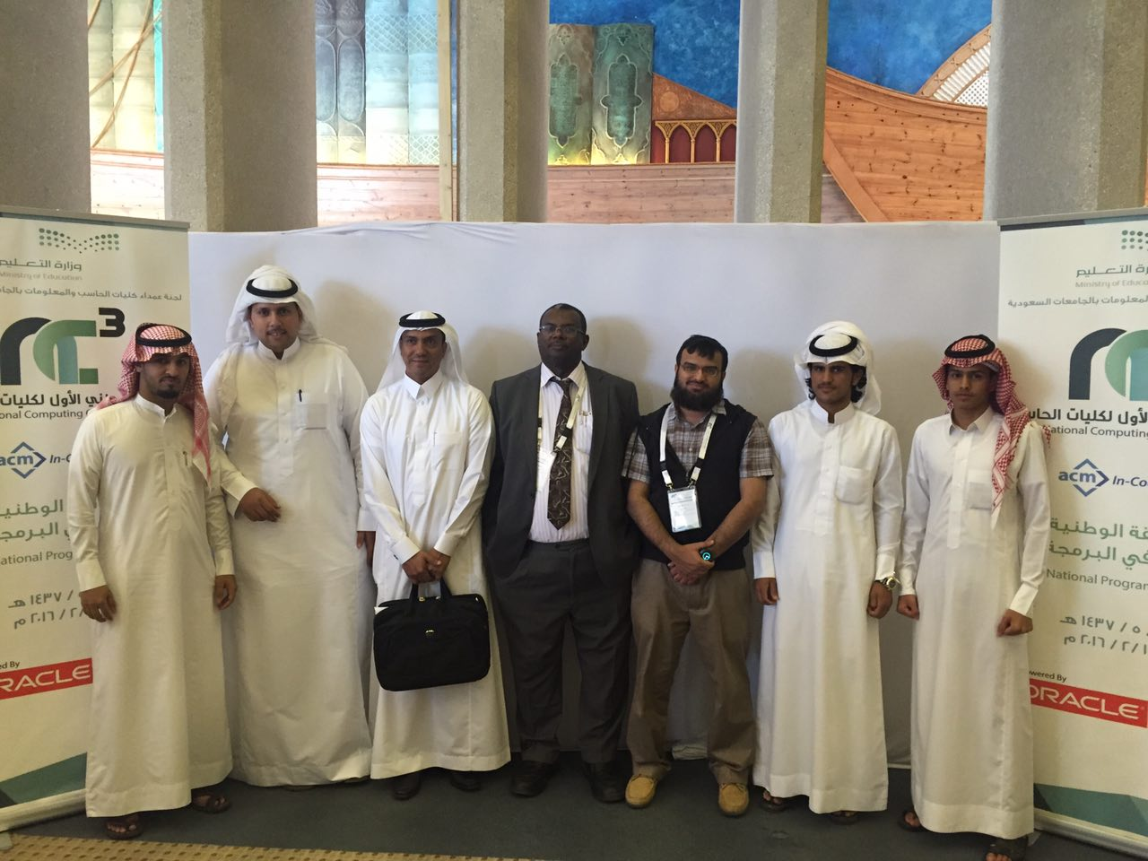

|  |  |  |
| --- | --- | --- |
| Coordinator | Computer Science and Information System | **College** |
| Dr. Abdullah Alabas  Dr. Khairan Rajab  Dr. Mohammed Alshargabi | Students’ Participation In the Sixth Scientific Conference | **Activity Title** |
|

1. **Alumni Committee**

Alumni Committee at the College of Computer Science & Information System offers employment and volunteer opportunities for graduate students seeking to develop their leadership skills while engaging with their peers and pervious alumni through a variety of programs and resources. Previous Alumni also are always welcome to attend any career event sponsored by the committee and will occasionally receive communication regarding on-campus events.

Since students spend much amount of time preparing for life outside the college, it is critical to evaluate whether the experiences they had in the college prompted well-lived life. This encompasses if they perceive that the college was a great fit for them, that they had professors who cared and made learning exciting and, most importantly, that their college prepared them well for life outside of the college.

* 1. **Prior Graduation**

Alumni Committee helps prepare graduate students to become innovative and creative leaders in the field they are applying for. We provide programs, services, individual assistance, and resources to enhance the academic, professional and career development of our college graduate students. In addition, we annually conduct a seminar for our graduate students, which helps them to write their resumes professionally and also to pass the job interviews successfully.

* 1. **After Graduation**

Aside from the fact that students left the college, it is befitting that we remain connected with our local and international alumni community after graduation. We very much want to hear from those of them who have graduated from our college living abroad or in Saudi

Arabia. We are always eager to hear about the milestones in their life -- any news about their life. Further, we as a committee should make sure that we could reach our students after graduation as we always encourage them to keep in touch with us through our website , email , and phone as well.

1. **Academic Advising**

Academic advising unit of CS and IS program governs by the college of CSIS aimed to provide the absolute guidance to students through efficacious counseling regarding students' academic and personal difficulties. Students are formed in a group according to their student ID and each group has been assigned to an academic advisor to ensure that all students get academic counseling throughout the program.

Each newly enrolled student is encouraged to meet his/her academic advisor and open a student file which should be kept and maintained by academic advisor as record. This file should reflect student progress mainly concerning on student's results. Academic advisors write a summary report on each student progress at the end of each semester and on the base of progress report, academic advisors produce a subject plan for the coming semester for each advisee student. After preparing a subject plan for a student, academic advisors are accountable to forward this plan to the academic advising unit and in parallel consult with the student about the proposed subject plan along with their expected graduation time frame.

The Deanship of Students Affairs at Najran University play a significant role in career counseling. This deanship helps expected to graduate students in their future career. Full time employees including professional are available within the deanship of student affairs. This deanship organizes an annual career day event to achieve the following goals:

* To provide university students with a wide spectrum of industrial companies and employers.
* To provide job opportunities to students.

Moreover, academic advisors (CS program & IS program) also provide some kinds of career advising to students. They help students on matters about searching for a job, preparation for interview, preparing their CVs. Note that the academic advisors provide counseling on career planning the graduating/higher level students depending on the students' necessity.

* 1. **Academic Advising Unit Tasks**
* Distribute the list of students at the beginning of each academic year or semester wise to academic advisors so that each advisor have a less than or equal twenty students.
* Conduct a meeting in the first week of each academic year / semester with new students and transferees to provide them with the necessary information for undergraduate study. Introduce them with their advisors and to explain the responsibilities of advisors and advisees are.
* Open a file for each student with his advisor.
* Provide all students’ documents (academic transcripts, timetable, and marks) to the advisors to follow-up students.
* The advisor will follow-up service required by the student, and find out the appropriate response to it.
  1. **Internal Student Academic Advising System**

The academic advising unit has developed a system to help academic advisors to perform the academic advising tasks effectively. The system also provides an opportunity to exchange information designed to help students reach their educational and career goals. the system assumes that the advising is a shared responsibility between an adviser and the student. Ultimately, it is the responsibility of the student to make decisions about his/her life goals by creating a plan to reach those goals. the following figures depicts the functions and task performed by the system.

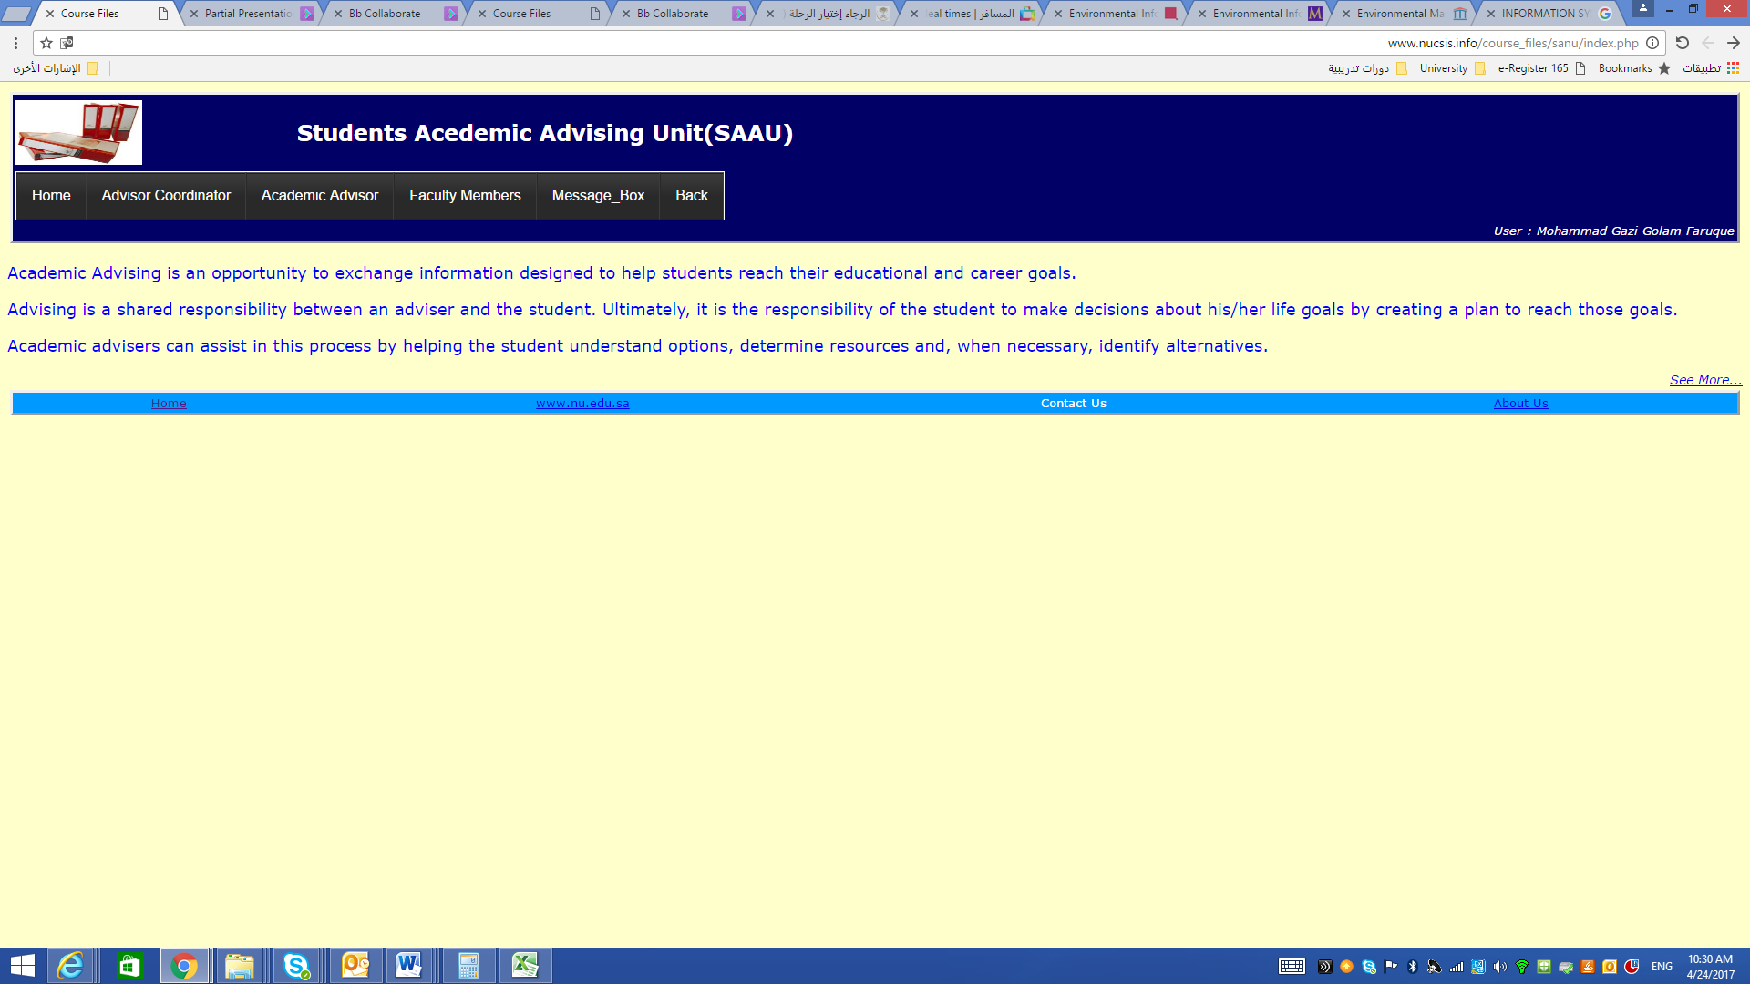

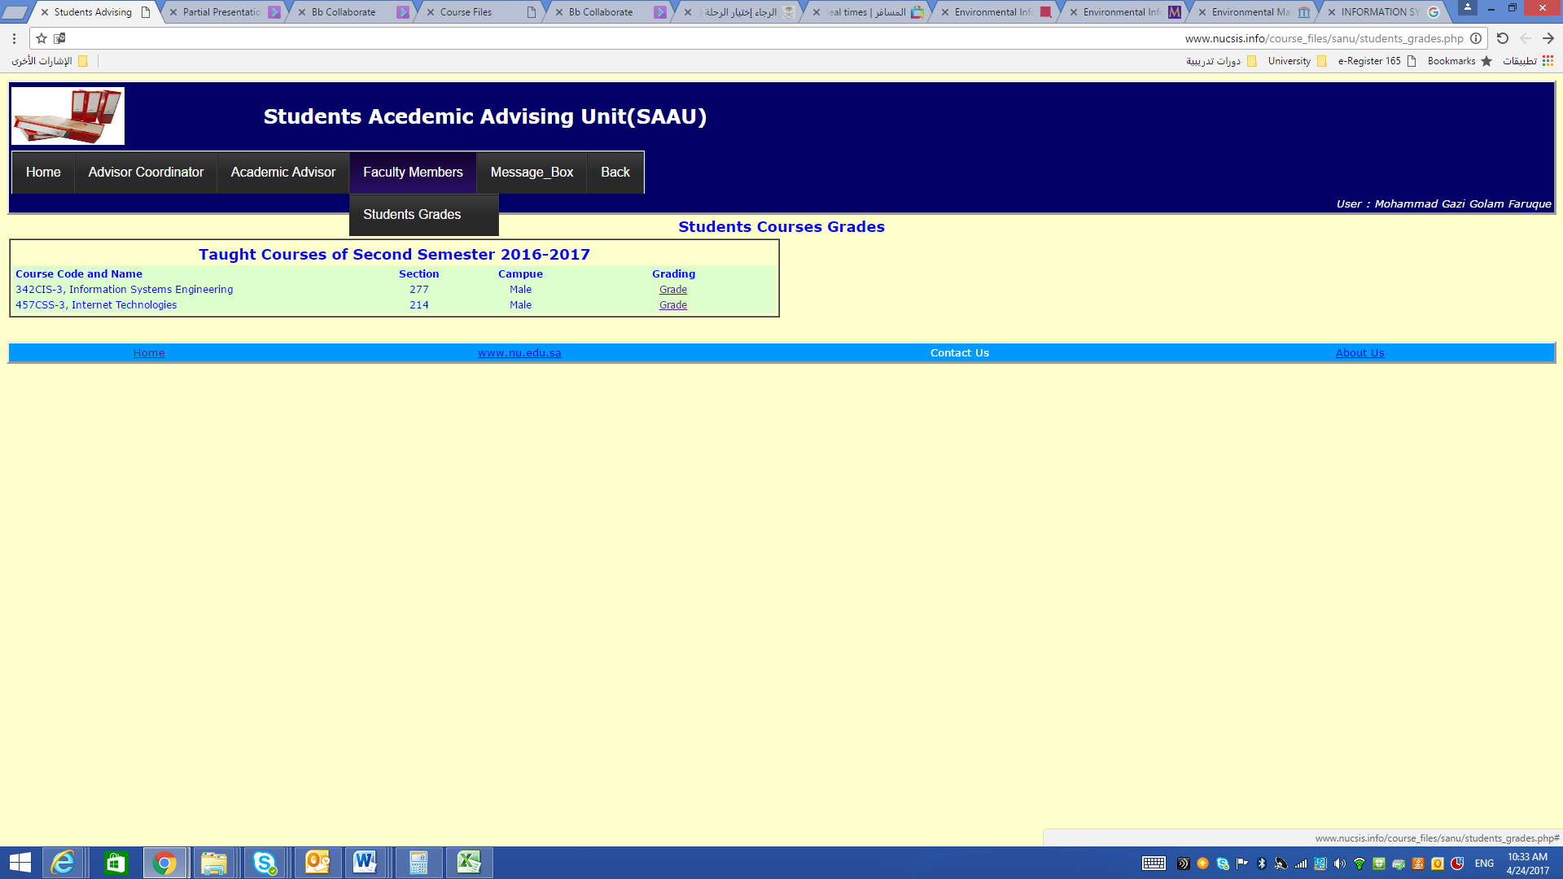

The faculty members can use the system to enter various type of data on the courses and students data such as the marks as shown in the following figure

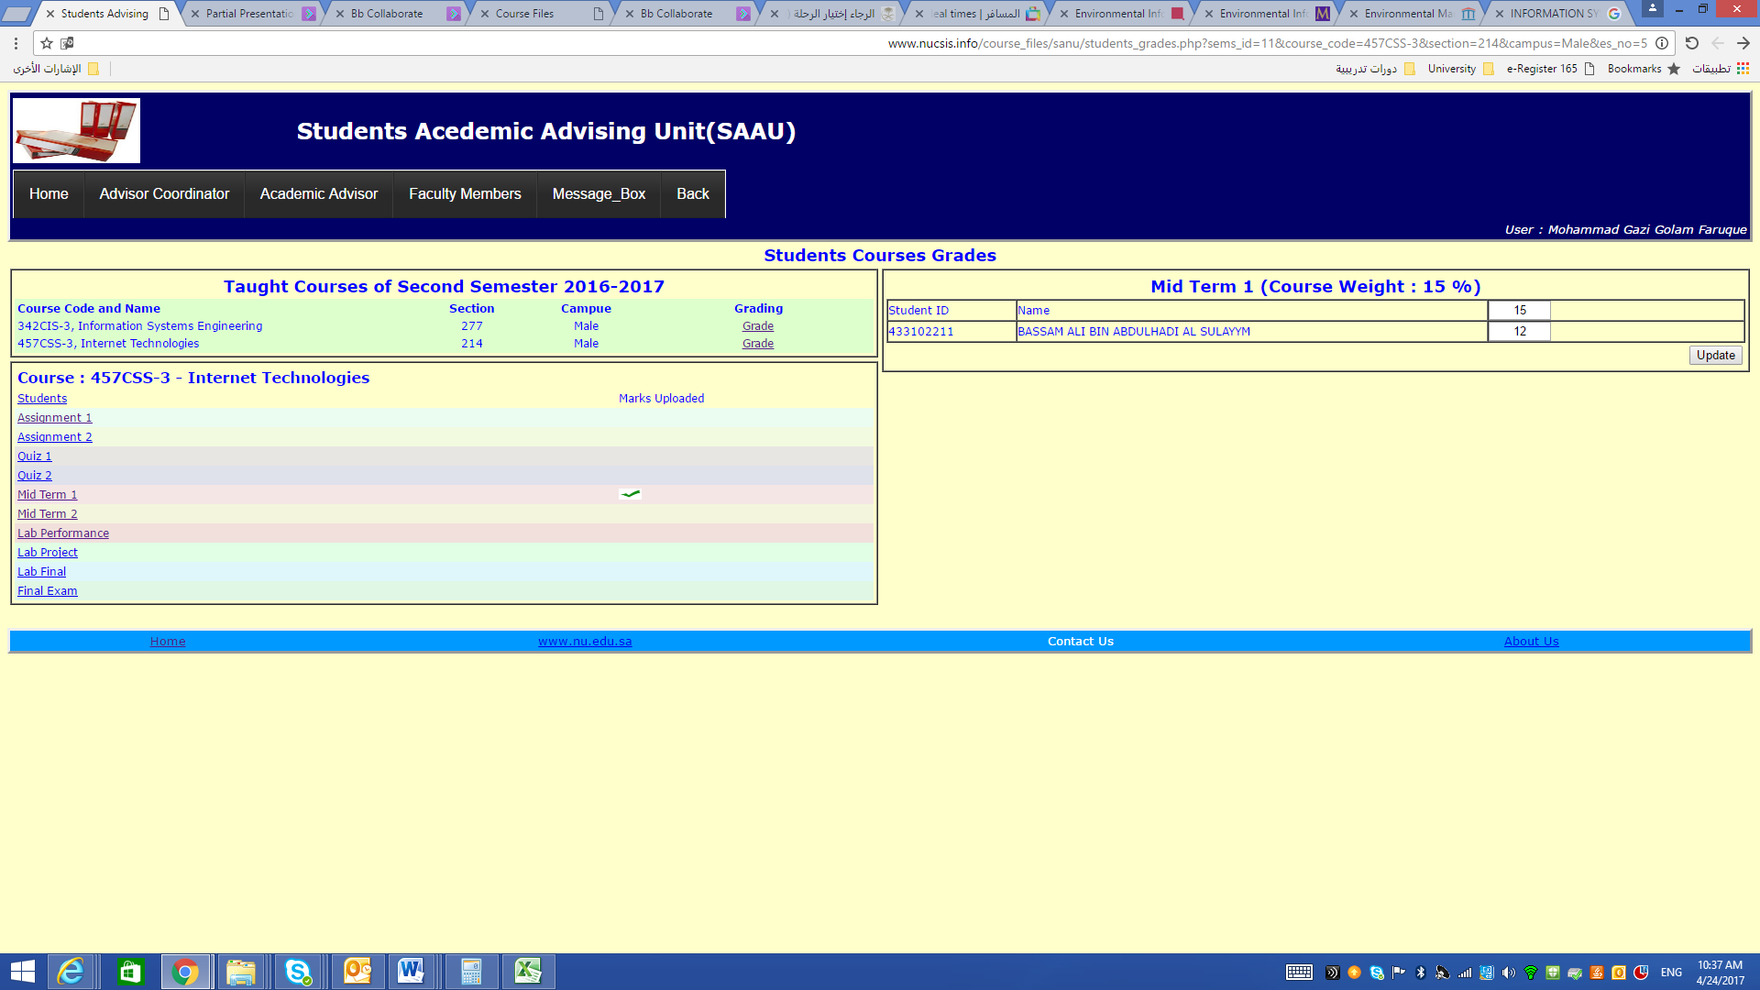

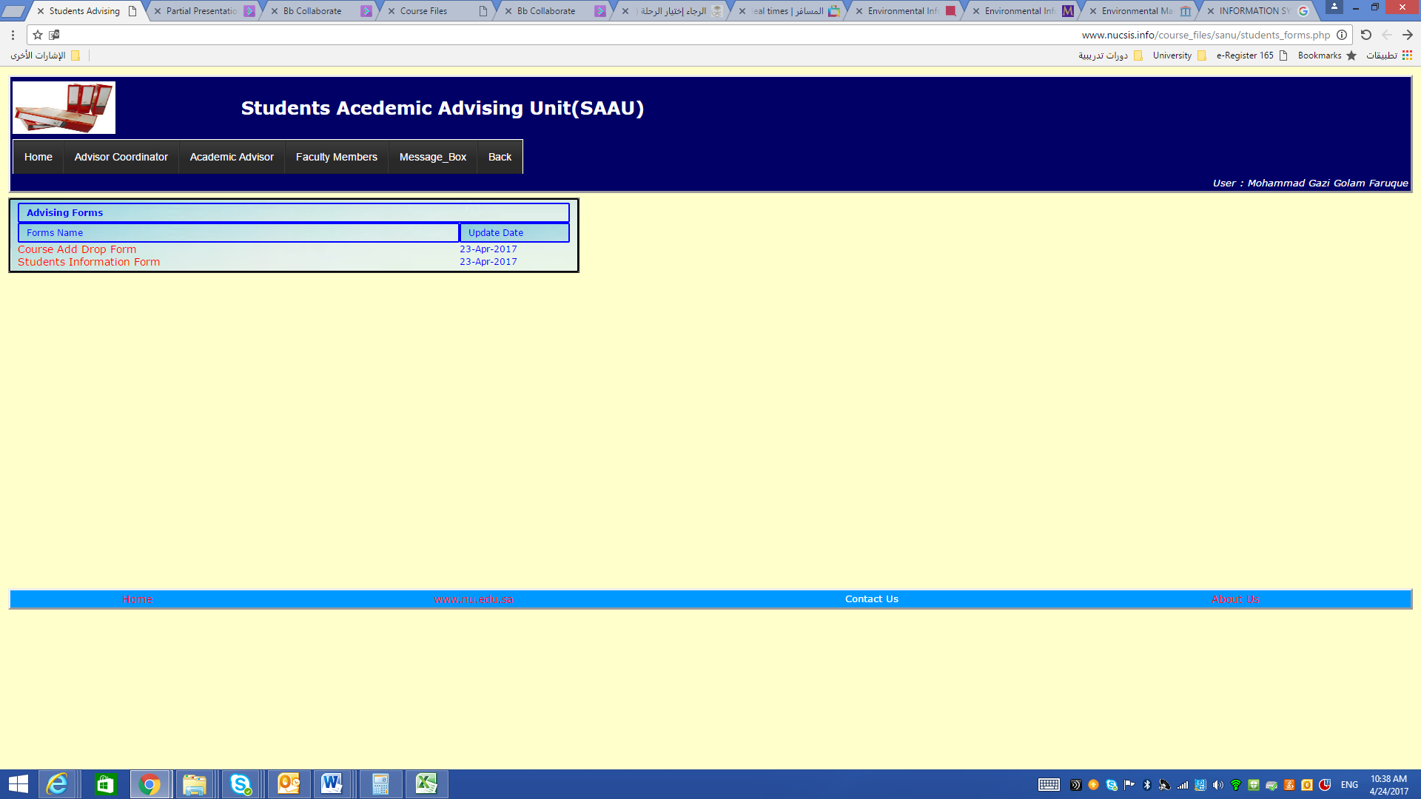

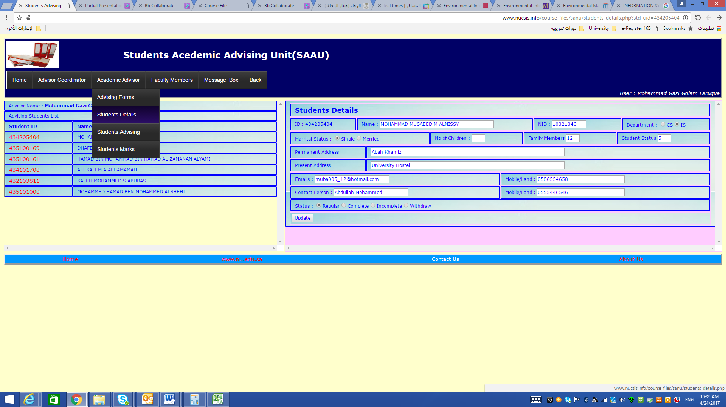

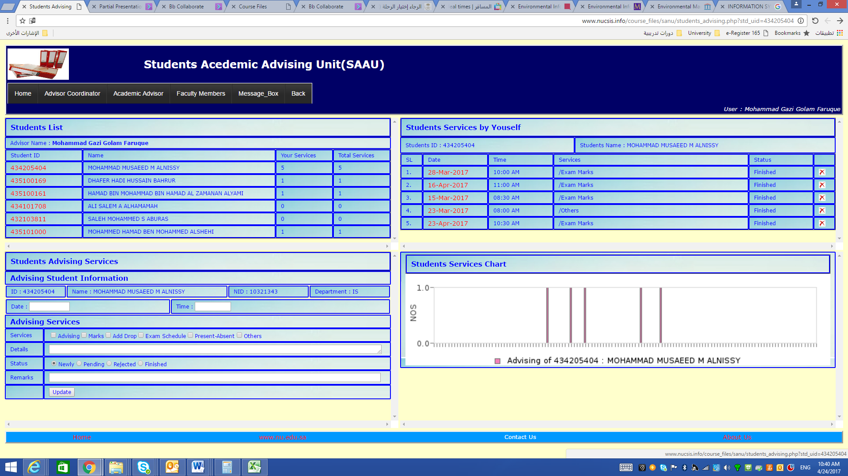

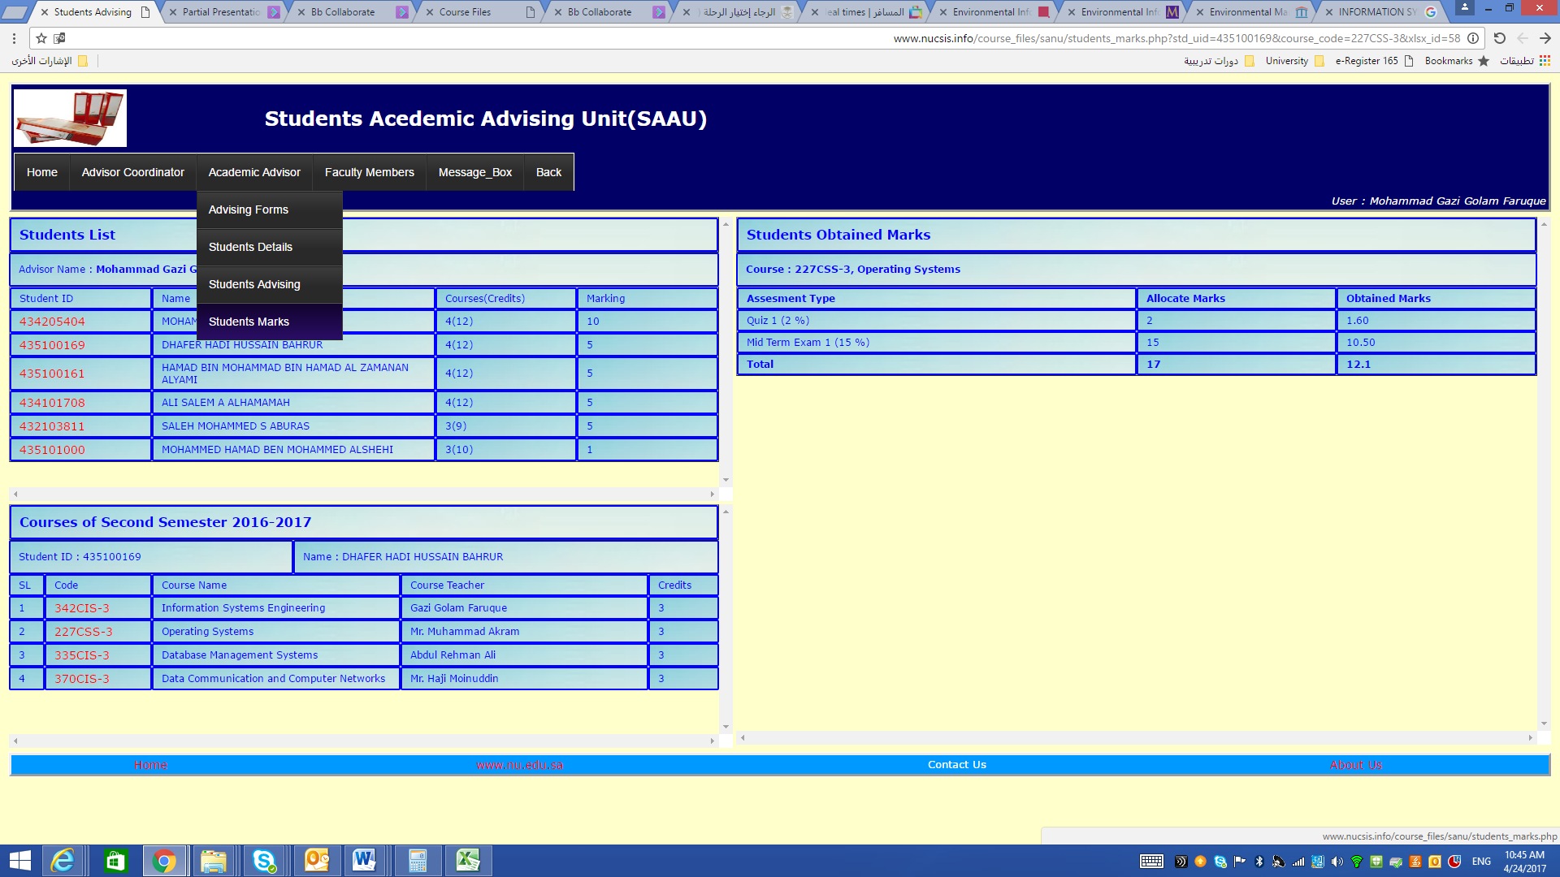

On the other academic advising coordinator can use the system to accomplish their tasks as shown in the following figures

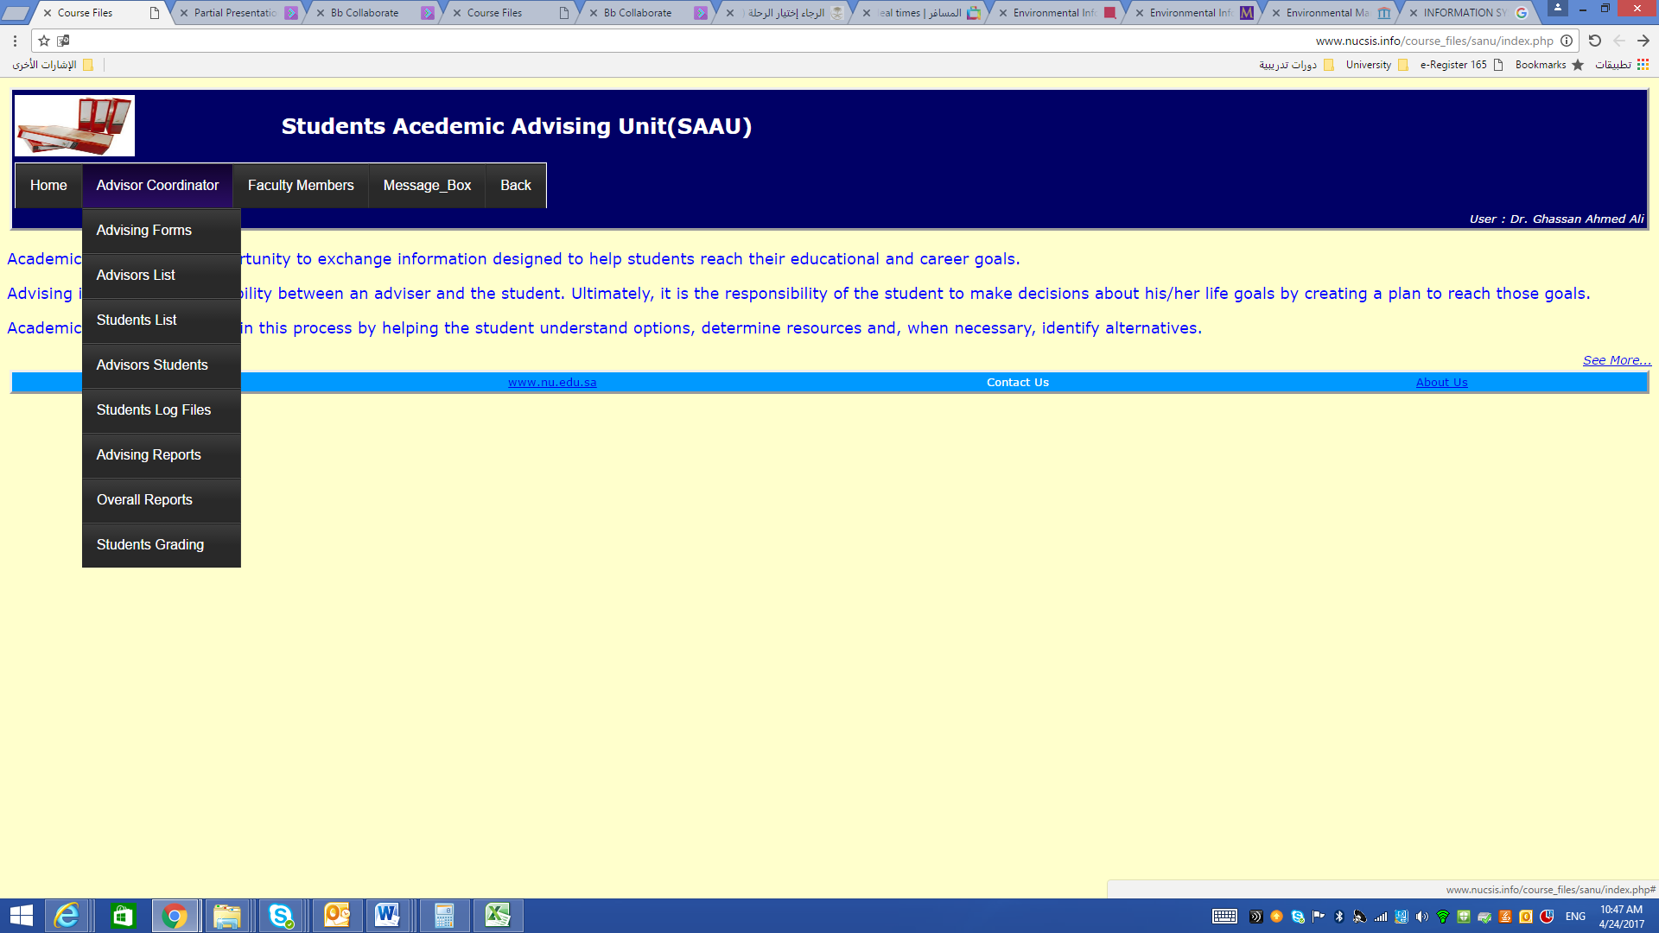

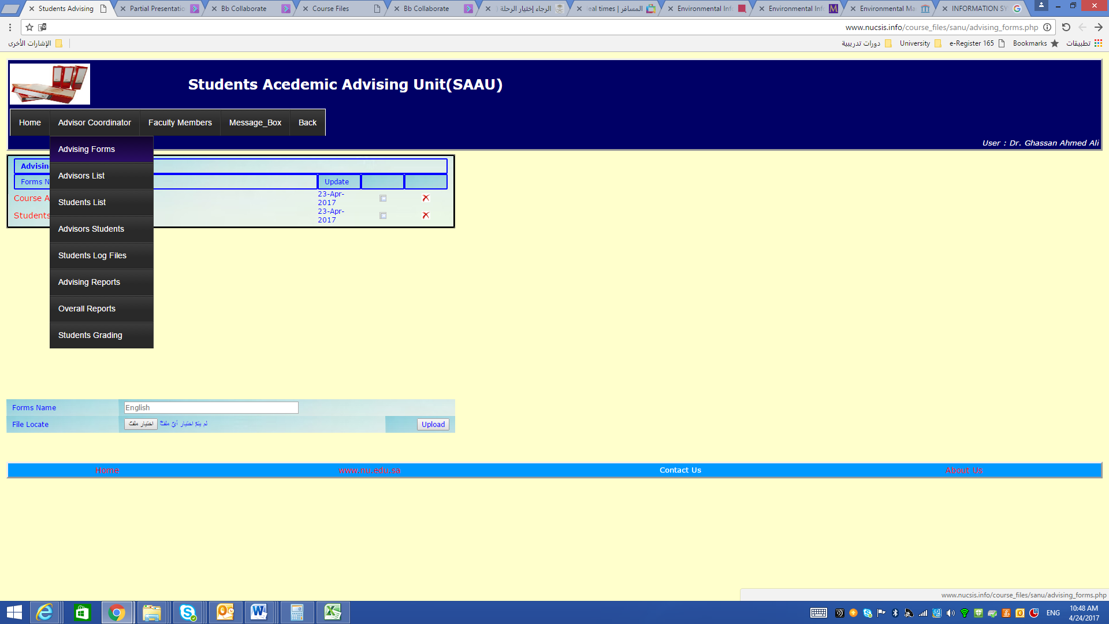

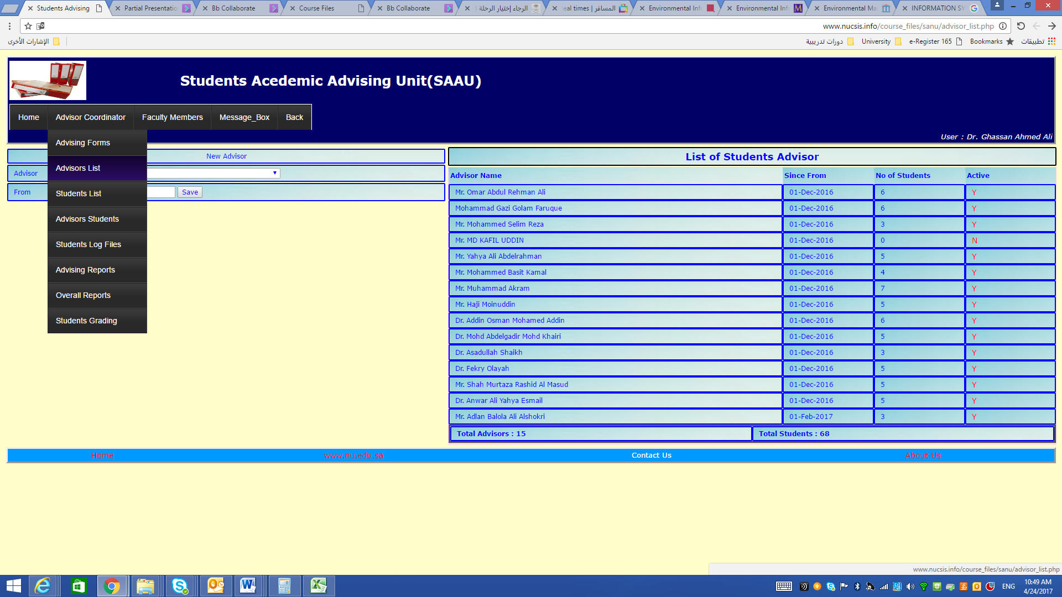

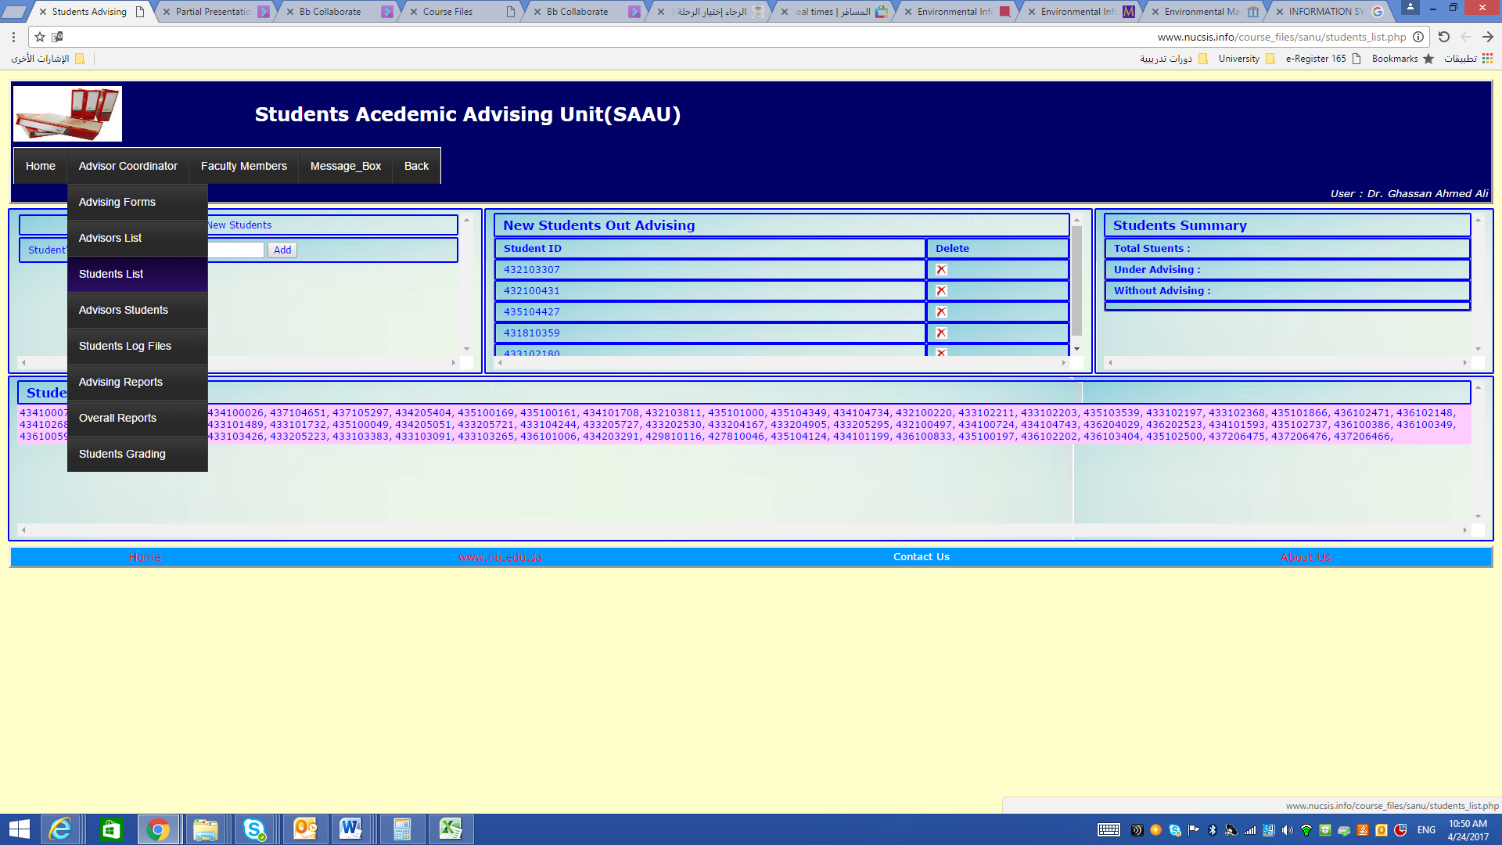

1. **Community Service**

In compliance with the strategic, plan of the Najran University several strategic project has been assigned in the current academic year 1436-1437. The plan of Community participation for the School of Computer Science and Information System was prepared by the Faculty Committee members in accordance with the university plan for 1436/1437 H. At each semester, the College of Computer Science and Information System depend on the specifics criteria's like Specialization ,Experience, Qualification and desire of faculty members.

The college of Computer Science and Information System intend to activate their role for community participation in order to make some contributions especially in computing field, which have been identified by the following areas.

* **First: Scientific Research and Conferences**

Members of faculty staff should expected participation by at least 5 researches that have a direct or indirect impact on the local society.

* **Second: Specialized Training Courses**

Expectedly, at least 4 specialized training courses in IT will be chosen and conducted.

(possible to conduct others training courses in case of need or requesting from the college)

* Specialized Course in Logical thinking for Programming.
* Specialized Course in Computer Networks.
* Specialized Course in Scientific Computer Science Terms.
* Specialized Course in Database.
* Specialized Course in Computer Building.
* Specialized Course in Web designing.
* Specialized Course in Basics of Project Graduation Preparation.

**Third: Scientific Seminars and Workshops**

Expectedly, at least 2 Seminars and workshops will be chosen and conducted. (possible to conduct others seminars in case of need or requesting from the college).

Computer Security

* A seminar for Backup.
* A seminar for computer benefits for religious and community
* Workshop in Speech skills
* A seminar in Computer Engineering Technologies
* Workshop in Technology usage for students motivations
* **Forth: Scientific Trips and Visiting**

Expectedly, at least 1 scientific trip per every academic year will be planned and conducted. (possible to conduct others scientific trip in case of need or requesting from the college).

* A scientific trip to Riyadh Visiting Cisco company and Al-Imam Muhammad ibn Saud Islamic University
* Visiting Deanship of Information Technology in Najran University.
* **Fifth: Other Area**

Expectedly, at least 1 activity should be conducted possible to conduct scientific activity in case of need or requesting from the college)

* Supervision on the computer science Olympics
* Inviting High schools in Najran region to visit College of Computer Science
* Participation in the annual Student Scientific Conference