التقرير الفصلي للإرشاد الأكاديمي
2018/2017

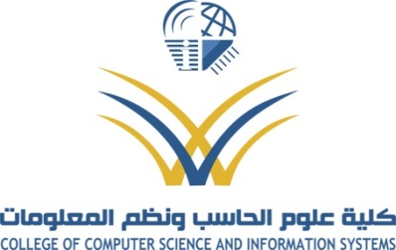

Students Distribution Mechanism:
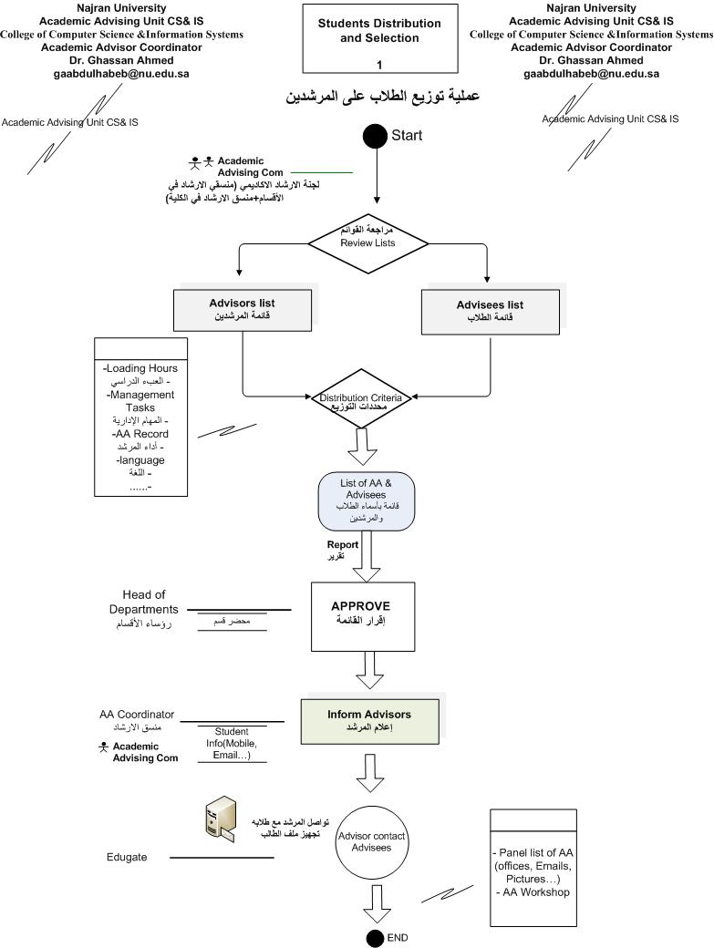

Students Distribution Mechanism
Factors related to AA Distribution: Advising Record of AA, Time table of AA, Record history of advising for advisor.
Factors related to Students Distribution: Level of student, record of Student
Academic Advisors AA (CS & IS)
Student Record
Level
Students Distribution
AA Efficiency
AA Load
Advising Record
Evaluation Every Semester
Students (CS & IS)

